

Women’s Education in Afghanistan: Activist, Taliban, and Ordinary Afghan People Views

Abdu Saboor Hamedi

abdul.hamedi@student.uiii.ac.id

Women’s Education in Afghanistan: Activist, Taliban, and Ordinary Afghan People Views

By:

Abdul Saboor Hamedi

A thesis submitted in partial fulfillment of the requirement for the degree of

Master Degree

In

Social Sciences

Indonesian International Islamic University

2023

Approved by

Chairperson of Supervisory Committee

©COPYRIGHT

By

Abdul Saboor Hamedi

Supervisors:

Supervisor 1 : Sirojudin Arif, Ph.D

Supervisor 2 : Nia Deliana, Ph.D

Table of Contents

List of Figures v

List of Tables vi

Abstract 1

CHAPTER I: INTRODUCTION 2

Research Problem 6

Research Question 7

Research Objective 8

Significant of study 9

CHAPTER II: THEORETICAL FRAMEWORK 11

Literature Review 11

Hypothesis 17

Argument 19

CHAPTER III: RESEARCH METHODOLOGY 21

Data Collection 22

Data Cleaning 24

Labeling Data 24

CHAPTER IV: ACTIVISTS', TALIBANS' AND AFGHANISTAN PEOPLE'S VIEWS ON WOMEN'S EDUCATION 34

Female Activists’ Top Frequent Words 44

Taliban and Ordinary People Perceptions 48

Analyzing the Frequency of Keywords Regarding Women’s Education 79

Taliban Top Frequent Words 80

Female Ordinary People Top Frequent Words 82

CHAPTER V : DISCUSSION 77

References 77

Appendix 102

# List of Figures

Figure 1:Sentiment Distribution (activists) 36

Figure 2: Extracting Tones of Five Keyword (activists) 38

Figure 3: Calculate Percentage Tones of Five Keywords (activists) 39

Figure 4: Sentiment Distribution on Women Education (activists) 40

Figure 5: Female Activists Top Frequent Words 45

Figure 6: Female Activists Word-Cloud 46

Figure 7: Male Activists Word-Cloud 46

Figure 8: Sentiment Distribution of 49

Figure 9: Sentiment Distribution of five Keywords 50

Figure 10: Activists and People 53

Figure 11: Sentiment Distibution on Keywords (women education) 77

Figure 12: Women Education Percentage 78

Figure 13: Frequency of Five Keywords by Group over Time 80

Figure 14: Taliban Top Frequent Words 81

Figure 15: Taliban Word-Cloud 82

Figure 16: Female Ordinary People Top Frequent Words 83

Figure 17: Female Ordinary Word-Cloud 83

Figure 18: Male Ordinary Word-Cloud 84

# List of Tables

Table 1:Tweets From Activists (Male & Female) 30

Table 2: Tweets From Taliban 31

Table 3: Tweets From Ordinary People (Female ) 32

Table 4: Tweets From Ordinary People (Male ) 33

Table 5: Calculate Sentiment Scores for Entire Dataset (activists) 41

Table 6: Calculate Sentiment Scores for Five Keywords (activists) 42

Table 7: Calculate Sentiment Scores for Women Education (activists) 42

Table 8: Sentiment Analysis of Tweets Containing the Keyword 54

Table 9: Tweets Related to five Keywords 54

Table 15. Fetch tweets by username 102

Table 16. Find related data by keywords 102

Table 17. Remove URL, and mention 103

Table 18. Top 10 Trends 103

Table 19. Remove Hashtags 103

Table 20. Expand Contractions 103

Table 21.Remove ASCII Characters 104

Table 22. Remove Whitespace 104

Table 23. Drop Null Values 104

Table 24. Remove Punctuations 104

Table 25. Contingency Code 104

Table 26. Transforming Textual to numeric 104

Table 27. Evaluate Performance 105

Table 28: Labeling Data 105

Table 29: Sentiment Analysis 105

Table 30: Sentiment Distribution 106

Table 31: Calculate Positive Tweets 106

Table 32: Code Scheme 106

Table 33: Anlyzing Five Keywords 107

Table 34: Average Sentiment Percentages 107

Table 35: Comparison of Sentiment Whole Tweets 107

Table 36: Comparison of Sentiment Five Keywords 108

Table 37: Comparison of Sentiment on Keyword Women Education 108

Table 38: Chi-square Test of Independence 108

Table 39: Cross-Tabulation of Sentiment and Gender 108

Table 40:Frequent Words 109

Table 41:Time Series 109

Table 42: Word-Cloud 110

Table 43: Comparison of Sentiment for Men Education Tweets 110

# Abstract

This study examines the topic of women’s education in Afghanistan from multiple perspectives, including those of activists, ordinary people, and Taliban officials. The study utilizes content analysis and sentiment analysis of tweets to investigate the levels and types of support for women’s education. Twitter posts from Afghan activists, Taliban officials, and Afghan individuals were collected to gather the necessary data.

The findings of the study reveal the existence of diverse perspectives and sentiments among the different groups. Activists, both male and female, demonstrate strong support for women’s education through active advocacy and promotion of equal access. The ordinary Afghan people also provides substantial support, albeit to a slightly lesser extent. In contrast, the Taliban exhibit limited interest or concern for the education of women.

To advance gender equality in education, the study underscores the importance of amplifying the voices of activists, addressing societal challenges, and advocating for legislative reforms. Policymakers, educators, and organizations in Afghanistan that are dedicated to improving women’s education and empowering women can benefit from the valuable insights generated by this research.

**Keywords:** Women, Girl, Education, University, School, Twitter

# CHAPTER I: INTRODUCTION

Millions of women, especially without equal educational experiences, skills, or qualifications, women of specific classes and social groups have long been doomed to inferior lives in terms of their capacity to grow personally, their choice of employment, their standing as citizens, and their ability to influence leadership and decisions at the national level that have an impact on their local lives (Weiner, 1986).

Women practically prevent from receiving education around the globe, especially in countries with patriarchal and conservative government forms. Afghanistan is one of those countries where women suffered for decades. Today, women are prevented from educating themselves, or the government has imposed restrictions on their education system. This restriction has a substantial negative impact on women’s daily activities. This limits their access to public gatherings, travel, study and other activities.

Studies show that educated women are more likely to have more opportunities, “better educated women that do work are more likely to work in non-farm activities (Anderson, Reynolds, Biscaye, Patwardhan, & Schmidt, 2021, p. 200).” Education for women has been cited as an important factor in the development of feminism by a number of authors. Women’s higher education institutions sprung up at the same time as the first waves of feminism in the United States, as noted by (Plutzer, 1993, p. 149).

The denial of education for women can have severe consequences for society and individuals (Orfan, 2021). Taliban restrictions on women’s education in Afghanistan have led to high illiteracy rates among Afghan women, which has limited their participation in society (Mashwani, 2017). The Taliban’s return has raised fears that women’s rights, including access to education, will be further diminished (Women, 2022). Despite Taliban efforts to limit women’s education, evidence shows that there is opposition among Afghans to this action.

A survey by Asia Foundation 2021 showed that 87% believed women should have equal access to education (Rieger, 2019). Hodes’ 2019 study found that Afghan women who receive an education are more supportive of gender equality and human rights. This study is necessary because it sheds light on the different views of groups, such as activists, Taliban and ordinary people. And it gives insight into Afghan society’s attitudes towards women’s education. Further, the researcher examines the tones of the tweets posted by three different groups of people, activists both male and female, the Taliban and ordinary Afghan people. Noteworthy, in the remaining chapters they researcher would only denote all three groups as, (activists, Taliban, and people).

The goal is to analyze the tweets and gauge their level of support for women’s education. In this analysis, the study looked at the sentiment distribution across several topics connected to women’s education and compute the percentage of positive tweets from women. Descriptive data are included, as well as a chi-square test of independence and a comparison of sentiment ratings across sexes and those between activists, Taliban officials, and ordinary people. The study wraps up with a review of the most popular phrases and terms that were found in the tweets.

The study uses quantitative content analysis to analyze the tweets and test the hypothesis as well as sentiment analysis to access to the tones of each tweet related to women’s education (Evans & Clark, 2015; Kitzie & Ghosh, 2016). Twitter operates as a network in which individuals rapidly disseminate and exchange thoughts, it possible for individuals to share their thoughts and feelings openly via the use of various forms of media, including text, photographs, videos, etc. (Karamouzas, Mademlis, & Pitas, 2022, p. 1).

Thus, these mediums can be utilized to track public opinion on a selected topic. Public opinion “represents the views, desires, and wants of the majority of a population concerning a certain issue, whether political, commercial, social, or other (El Barachi, AlKhatib, Mathew, & Oroumchian, 2021, p. 1)” Further, the researcher uses the Python programming language to analyze the tweets. Python programming language is quickly becoming one of the most widely used for computational science.

It is attractive for algorithm creation and exploratory data analysis because of its high-level interactive character and growing ecosystem of scientific libraries (Pedregosa, 2011, p. 2826). Also, Python is one of the most efficient and compatible programming languages for analyzing data and has thousands of libraries, also, the researcher uses several libraries, such as Pandas and NumPy, scikit-learn, these libraries allow us to understand our data and analyze them based on the study’s requirements.

A comprehensive literature analysis addresses the restriction on Afghan women regarding education, cover the historical, cultural backdrop, and the conflict, that impact on women’s lives, and the role that gender and ethnicity play in determining views regarding women’s educational opportunities. In the following section of the study talks related to the research problem, objective, and significant of the study. The researcher is committed to analyze the ramifications of these results and provide suggestions for further study and policy changes to advance gender equality and women’s rights in Afghanistan.

# Research Problem

Despite some progress made in recent years, Afghan women still remain significantly away from education with barriers that hinders them from going to school and achieving educations. Understanding and addressing these barriers is crucial for advancing women’s education in Afghanistan. One aspect that deserves attention is the differing perspectives among activists, Taliban, and ordinary people regarding women’s education.

Activists, both male and female, play a pivotal role in advocating for equal educational opportunities for Afghan women. They recognize the transformative power of education in empowering women, improving their socio-economic prospects, and promoting gender equality. However, it is essential to acknowledge that male and female activists may experience and perceive these challenges differently due to societal expectations and gender roles. Exploring these nuances can provide valuable insights into the specific obstacles faced by both male and female activists and the strategies they employ to overcome them.

The goal is to pay attention on difference in the views of activists, Taliban, and ordinary people, and how gender affect male and female activist views regarding women’s education. We seek to understand the complexity of social, cultural, poverty, conflict and political factors that influences the views of people regarding women’s access to education with a focus on the effect of gender norms.

# Research Question

The aims to investigate on the difference in perspectives of activists, Taliban and the ordinary Afghan people, and how gender affect male and female activist regarding women’s education. The research question to be answered is: “What are the differing views among Activists, Taliban, and Ordinary Afghan People Regarding women's education, and how gender affects activists’ views about women’s education?” The study uses Twitter data to discover if there are any gender-based trends or inequalities in how people feel about lifting the restriction on women’s education. It stresses the necessity of destroying oppressive systems to realize gender equality.

Data was gathered from Twitter, a widely used social media platform, and analyzed using content analysis techniques to see how people feel about the topic. The study attempts to illuminate the complexity of gender and its role in forming attitudes regarding women’s education by investigating patterns and trends on three groups, activists, Taliban, and ordinary people. The findings will help educated people and those fighting for gender equality in the classroom better understand Afghan women’s obstacles and inequities while trying to get an education.

# Research Objective

In recent years, scholars have paid attention to issues that affect women, including access to education, equality, participation in politics, and other aspects of life that women usually face with difficulties. There are a number of reasons behind unequal education, one of the reasons that most of the scholars quote, is that “higher education research has traditionally been framed within a masculine paradigm, often with man participants (Parson, 2020, p. 515)”. Other than masculinity, conflict effects women’s education, especially countries like Afghanistan, which has experienced civil and international wars for decades.

This study aims to explore how gender shapes activists views of women access to education, and to find what are the perspectives of activists, Taliban and ordinary Afghan people. The researcher dives into the views and personal experiences of individual Afghan people. Paying attention to how gender shapes their vision or ideas and influences their views on women access to educational opportunities. The study focuses on recognizing various facts that contributing to attitudes toward women’s education in Afghanistan, considering culture, economic, conflict, social aspects. We believe, by examining these factors reader can gain a deeper understanding of complexity that prevent women from education in the country.

The study will help better understand Afghan women’s difficulties when accessing education. It will also examine the relationship between gender ­­­and people’s views. The study promotes gender equality, improves women’s education access in Afghanistan, and helps promote human rights and social justice in Afghanistan.

# Significant of study

The significance of this study lies in its focus on gender as a factor in how people see women’s educational opportunities in Afghanistan. Understanding the cultural and societal elements that contribute to gender imbalance in schooling can be gained through the analysis of tweets from Afghan people, and this study aims to do just that. As a result, the study will benefit the academic community by providing new insights into this pressing topic and demonstrating the value of social media as a resource for scholars in Afghanistan and beyond.

Furthermore, this study will be one of the first to extensively investigate the difference on perspectives of activists, Taliban and Afghan people regarding women’s access to education through social media. By giving them a stronger voice through social media, this study will help improve conditions for female students in Afghanistan. In doing so, it will shed light on the achievements and challenges faced by Afghan women and inspire future generations of women to pursue education and careers.

The study seeks to shed light on the power of social media to advance gender equality and elevate underrepresented communities’ voices. The difficulties Afghan women encounter in gaining access to education can be better understood by studying tweets from Afghans both inside and outside of Afghanistan. These results will provide the foundation for future efforts to advance gender equality in the classroom and beyond. This research acknowledges the special challenges faced by Afghan women and sets out to shine a light on such obstacles in the hopes of inspiring change. By sharing our findings, we want to encourage further discussion about how social media may help advance gender and political equality.

This study holds significant importance as it brings attention to the critical issue of women’s education in Afghanistan and the concerning public opinion that tends to hinder their access to education. By employing Twitter as a data collection tool, this research will contribute to the expanding literature on the gender imbalance in education. The resulting findings are expected to inspire further investigations into the intricate relationship between gender dynamics and social media in Afghanistan and other contexts worldwide. By deepening our understanding of these dynamics, we can effectively address the challenges that women face in pursuing education and work towards creating more inclusive educational environments.

# CHAPTER II: THEORETICAL FRAMEWORK

## Literature Review

This study looks at women’s education in Afghanistan from the views of activists, Taliban, and ordinary Afghan people and how gender affects male and female activists views on women’s education. While there has been progress in this area, there are still challenges that women in Afghanistan confront when attempting to enhance their education. The lack of resources, including schools, contributes to these issues, as do issues like poverty and cultural norms, as well as war and violence. Studies reveal that educated women have more opportunities and contribute more to non-farming activities, highlighting the value of education in empowering women and fostering gender equality (Anderson, Reynolds, Biscaye, Patwardhan, & Schmidt, 2021).

In exploring activists’ perspectives on women’s education and their support for gender equality, it is essential to recognize that activism encompasses a range of activities driven by social, political, and personal beliefs. Consumer educators aiming to redefine consumer education approaches can be seen as consumer activists, advocating for the intricate connections between consumers and the marketplace, encompassing political, social, and economic dimensions (McGregor, 2015).

For instance, Laura Lyytikäinen (2013) delves into the construction of activist identity within the Russian opposition movement Oborona. Lyytikäinen’s study examines how gender, class, and the civic field influence the complex nature of activist identity. Oborona, founded by young Russians opposing Vladimir Putin’s government, has undertaken various actions such as protests, demonstrations, and hunger strikes (Lyytikäinen, 2013). According to Lyytikäinen, most activists within this movement espouse democratic ideas, with well-educated parents who hold professions such as teachers, doctors, and scientists, indicating a solid educational background among the activists. This action of activists shows that they not only stand with women’s education but also stands againsts any inequality that causes harm to individuals. As Carla Luguetti and Kimberly L. Oliver (2020) say, the activist approach can help teacher educators, student teachers, and young people to become conscious of the power structures in society that lead to social inequities (Luguetti & Oliver, 2020).

Similarly, Lauri Johnson (2004) sheds light on women’s education from the perspective of activists. African American women teachers in Harlem during the 1930s, 1940s, and 1950s were not only dedicated to providing their students with a high-quality education but also actively engaged in social reform movements, teacher union organizing, and civil rights activities. These activist educators leveraged their influence to drive broader societal change, improve working conditions for teachers, and expand access to higher education. Their efforts had a transformative impact on the lives of African Americans and paved the way for subsequent generations of activists and educators in Harlem (Johnson, 2004).

Rebecca M. Klenk (2010) talks about how gender shapes activists’ views on women’s access to education. The activists at Lakshmi Ashram had quite different views on the importance of women’s education, depending on their gender. Male activists saw education as a means to advance women’s economic standing, with an eye toward creating more and better employment options and greater economic autonomy. They expected that through gaining an education, women would become more self-reliant and make greater contributions to their families and communities.

However, the women activists at Lakshmi Ashram regarded education as a means to combat gender inequity and boost women’s agency. They thought getting an education would empower women to break free from societal norms and actively shape their communities (Klenk, 2010). These perspectives shaped male and female campaigners’ tactics. Female activists concentrated on changing social norms around women’s education to remove impediments to women’s education, while male activists focused on financial support. Female campaigners faced family and community opposition to women’s education. Male activists, seen as better social change leaders, were more accepted by policymakers.

Lakshmi Ashram’s male and female activists championed women’s education despite obstacles. They thought it empowered women and developed communities. They persistently fought for decent education for women. Further, Barbara J. Bank (2007) “activists seeking sex equity and participants in the emerging discipline of women’s studies (Bank, 2007)”.

To understand the views of the Taliban and ordinary people regarding women’s access to education, we must recognize the influence of action resources like knowledge and skills, which empower individuals to shape their own lives. Modernization plays a crucial role in fostering political involvement through economic growth, education, and personal independence. Societal values reflect the impact of industrialization and the ongoing conflict between survival-oriented and self-expression values. Self-expression societies prioritize personal fulfillment, active participation, gender equality, tolerance, trust, civil liberties, democracy, and responsive governance (Welzel & Inglehart, 2008).

To have glance on Afghanistan, it’s palce where women’s rights oppressed for decades (1992-1996) (Fluri, 2009, p. 260) thus, one must analyze Afghanistan’s women’s situation within the larger historical context of Afghanistan, not through the ideological formulation of “before and after” the Taliban. Only such a perspective can ensure that women are seen as essential to rebuilding Afghanistan. In this regarding Ruth Ren (2010) has launched a public survey to measure people’s opinion regarding women’s education, by asking “Women should have equal opportunities like men in education” over 87% responded agree with women’s education and 50% “who strongly agree” (Rene, 2010) according to the report only around 11% disagree, report highlights, a higher proportion of women 93% than men 82% support for equal opportunities in education.

When looking to the views of the Taliban regarding women’s education, from 1994 they have disagreed with women’s education and work, as Pia Karlsson & Amir Mansory (2008) say “when the Taliban (students of Islam) entered the arena and installed law and order - at the cost of human rights abuse. In particular women and girls in the cities were denied work and education opportunities” (Karlsson & Mansory, 2008, p. 3).

Saira Inayatullah (2022) also launched a study regarding women's education in 2022 after the collapse of Afghanistan to the Taliban, people express their concern related to women’s education as Inayatullah asks participants, and they said, “now after the Taliban, women education has reached nearly zero and it has turned into a dream we don’t know if it's achievable or not” (Inayatullah, 2022, p. 28), while the second participant answered, “now the Taliban break every single foundation that was built for women's education”, and the third participants say, “A pre-Taliban Afghanistan was good. We had a comfortable life. Education service was accessible to everyone. Now, the Taliban don’t allow girls to go to school.”

Considering all respective scholars’ arguments, we believe activists have high support for women’s education, and this is not concise on women’s education only; their goals are to push for equality, both males and females. They support equality because they want to build a strong community and women self-sufficient. According to Ruth Ren (2010), over 87% of ordinary Afghan people support women’s education as long as the Taliban is concerned. According to several studies (Yousaf & Jabarkhail, 2021; Inayatullah, 2022) they have no interest in women’s education.

## Hypothesis

H1: The Taliban’s views regarding women’s education will be significantly more restrictive and opposed than those of activists and ordinary Afghan people. This hypothesis can be explained theoretically by the Taliban’s ideology and prior behaviour. The Taliban, an Islamic extremist party that ruled Afghanistan from 1996 to 2001, imposed severe Islamic legislation, including limitations on women’s education and work. Women were punished for attending school or working outside the home. Fundamentalist Islam and gender roles underpin the Taliban’s attitude. Based on their philosophy and past actions, the Taliban’s views on women's education are likely to be more restrictive and opposed than those of activists and ordinary Afghans. 1996 that violence against women and girls was a "daily reality throughout the world," and that the Taliban "drastically" curtailed women’s rights (Skaine, 2002).

H2: Activists are more likely to demonstrate higher support for women’s education compared to both the Taliban and ordinary Afghan people. Women’s education holds huge significance and is a matter of ongoing contention. It serves as a vital solution to address numerous issues that affect women’s lives. Although steps have been made to promote its expansion, women’s education continues to face obstacles stemming from societal customs, entrenched power dynamics, and the failure of governments and nations to take effective measures (Nussbaum, 2004). To see women’s education from the prespective of activsts who campaign for women’s rights and education will likely see education as a fundamental right for all individuals, regardless of gender. They support the empowerment of women through education and equality.

On the other hand, the Taliban has a history of opposing women’s education and viewing it as a threat to traditional gender roles (Telesetskyt, 1998). Ordinary Afghan people may hold varying views towards women’s education, depending on factors such as their level of education, religious beliefs, and cultural background. Generally, those who prioritize gender equality and women’s rights are more likely to support women’s education than those who do not. Hence, it is expected that activists would show higher support for women's education as compared to both the Taliban and ordinary Afghan people.

H3: Female activists are more likely to hold higher sentiments for supporting women’s education compared to male activists. Women’s education is generally a top priority for female activists since they have a better understanding of the challenges women experience in gaining an education. On the other hand, male campaigners might not place the same value on women’s education as their female counterparts do. The perspectives of men and women on education and women’s rights may still be influenced by society standards and gender roles. Gender, according to feminism theory, is a social construction, and gender norms and expectations are internalized via upbringing in a patriarchal society (Lorber, 2001). Therefore, due to their gendered attitudes and ideas, female activists are more inclined to advocate for women’s educational opportunities.

## Argument

In the realm of women’s education, a battleground of ideas and beliefs emerges, where activists, the Taliban, and ordinary Afghan people engage in a theoretical struggle over the significance and role of education in the lives of women. From the activist’s view point, grounded in feminist theories, education becomes a powerful tool for emancipation and social change. Activists, driven by their social, political, and personal beliefs, perceive education as a fundamental right, essential for the empowerment of women. In their view, education opens doors to opportunities, enabling women to challenge societal norms, break free from oppressive systems, and actively shape their communities. Guided by feminist frameworks that recognize the intersectionality of gender (Lorber, 2001), class, and civic engagement, these activists strive to remove barriers and advocate for women’s educational access.

Conversely, the Taliban’s theoretical stance on women’s education presents a stark contrast. Driven by an ideology rooted in religious fundamentalism and traditional gender roles, the Taliban perceives women’s education as a threat to their established order. In their worldview, education for women undermines the status quo and challenges the patriarchal structures they seek to uphold. Thus, the Taliban imposes severe limitations on women's access to education, perpetuating oppressive systems and hindering progress towards gender equality (Franks, 2003).

Ordinary Afghan people, each with their own theoretical perspectives shaped by education, religious beliefs, and cultural backgrounds. These perspectives vary across the spectrum, reflecting the complex societal fabric of Afghanistan. Some embrace the ideals put forth by activists, recognizing the transformative power of education and the imperative to ensure equal opportunities for women. Others, influenced by societal norms and traditional values, may hold reservations or even oppose women’s education, subscribing to a theoretical framework that reinforces traditional gender roles and norms (Rene, 2010).

# CHAPTER III: RESEARCH METHODOLOGY

To test the hypothesis, the study have used content analysis (Evans & Clark, 2015), It is offered here and comprises of a set of methods we created for conducting systematic analyses of texts. Twenty years ago, researchers examined the mental and emotional effects of being unemployed in a longitudinal study (Mayring, 2004). To check the tones of the tweets related to women’s education, we use sentiment analysis also, known as opinion mining refers to the study of how individuals feel about certain thing. The entities can be things like goods and services, businesses and people, places and things, ideas and concepts. There is a lot of room for potential issues in this subject. Sentiment analysis encompasses a wide range of activities formerly performed under several titles, such as opinion mining, opinion analysis, opinion extraction, subjectivity analysis, affect analysis, emotion analysis, and review mining (Liu, 2015).

Alos, chi-square used, which evaluates the consistency between an observed percentage and theoretical predictions; test for statistical significance between two variables often representing nominal or ordinal levels of measurement (Lewis & Burke, 1949), also, it is common practice to use cross tabulation (crosstab) as an analysis method to compare the outcomes of one or more variables with those of another.

## Data Collection

Data collection began between December, 01, 2022, and March, 30, 2023, the used free Twitter application programming interface (API), this API allows individual to retrive up to 3200 maximum rows from a singl account (Kitzie & Ghosh, 2016). The researcher in this study analyzes three different groups of tweets, namely: Activists, both male and female; Taliban officials, since there is no female on the Taliban’s cabinet, thus the study only focuses on the male side, last but not least, ordinary Afghan people, male and female, not by gender but in general, eventhough there are an equal amount of sample for both.

Researcher have individually collected the tweets, and there are three different approaches to recognizing the activists, to fetch their tweets. First, the we have joined the Afghan Twitter spaces, to recognize activists from there. The second approach, finding Afghan activists through google. The third approach is, activists have been frequently invited by Afghanistan’s TV, there are several TV channels which has hundreds of followers and views inviting activists in daily bases. E.g., [TOLOnews](https://twitter.com/TOLOnews), [ArianaNews](https://twitter.com/ArianaNews_).

For the Taliban officials, there is a single approach, which is [Zabehulah_M33](https://twitter.com/Zabehulah_M33), and “Official Twitter Account of the Spokesman of Islamic Emirate of Afghanistan, Zabihullah Mujahid”. This is the official account of the Taliban spokesman, and Zabihullah has followed other officials; it provides an easy way to recognize the officials and fetch their tweets.

The researcher have done the same approachn on [mobeenkhan1231](https://twitter.com/mobeenkhan1231). Mobeen is a famous person on social media. He is an active member of the Taliban, most of the Taliban has followed him on Twitter, this gives us more ability to access Taliban officials to access to their tweets.

Related to the ordinary people, the researcher have implemented the same approach but this time, on Tolo News and Ariana News “[TOLOnews](https://twitter.com/TOLOnews),  [ArianaNews](https://twitter.com/ArianaNews_)”. It gives us ability to recognize Afghan people from their followers or on the comment section, because mostly people use either Pashtu or Persian (Dari) language to comment on a post. To analyze the data researcher has taken a sample which consists of 54 different Twitter users, whether its activists are the Taliban, but the number of tweets could be different, dependent on the users and how active they are. The duration of data collection starts from 2021, December, 01 to 2023, March, 30.

## Data Cleaning

It’s the procedure of finding wrong information, fixing it by eliminating unnecessary bits, and re-entering the right ones. Data cleansing include eliminating mistakes and verifying information. Cross-checking data is a viable option for fixing this problem. Problems usually disappear after data is checked for accuracy.

The obtained dataset is cleaned up before analysis to reduce time and effort. All the information is changed to lowercase and any slang or unnecessary terms are eliminated. URLs and textual references are also omitted since they are unnecessary for analysis.

Eliminating frequent, brief function words (such as pronouns, prepositions, conjunctions, abbreviations, interjections, etc.) that are still essential to language syntax is known as "removing stopwords" from a corpus. Is, but, and, which, on, any, and some are all examples of stopwords. A text file containing a list of stopwords may be used to remove them from any language written in the Latin script (Domagoj Margan, 2015).

## Labeling Data

Labeling the tweets gives us more access to those tweets which talks related to women’s education. In another word, one can differentiate which tweets are related to education which are not. The researcher have labeled data using five different keywords. As our depedent variables are women and education, and we have also selected “girls” which is refere as “women” as well, and the three other keywords frequently appears on our tweets and mostly people use those keywords to talk about women’s education on Twitter, especially in the case of our study.The keywords are as follows: “Eeducation,” “School,” “University,” “Women,” and “Girl”.

These keywords labled as one (1) which means the tweet related to education, while zero (0) means the tweets are neutral or not talking about education. Also, tweets like “beautiful women”, or “good school” has removed from the dataset, unless tweets that talks about the current study, such as “women banned from education”, or “girls cannot go to school”, and other tweets which talks related to education. Further, the dataset labled through machine learning using Pythong Programming Language.

The keyword: “Women Education”. This is a single keyword that consists of two words, this exactly focusing on women’s education, by breaking down the data into a small piece and analyze only those tweets which has Keyword of “Women Education”. Overall, the data analysis method shed light on the three different groups: Activsts, the Taliban and people in Afghanistan their patterns of behavior over the course of the study’s three-month duration. Interesting trends and patterns, as well as connections between the various groups, were uncovered by the investigation

|  |  |  |  |
| --- | --- | --- | --- |
| Male | | Female | |
| Unclean | Clean | Unclean | Clean |
| remember world let taliban get away completely banning women education five years one hundred ninety nine | remember world let taliban get away completely banning women education five years | Please support women education Afghanistan | please support women education afghanistan |
| Women in Afghanistan after the return of the Dark ages—Taliban rule. | women afghanistan return dark ages taliban rule | Almost one Month since surrender Kabul Taliban banned women girl, work, media, sports, and Music Public | almost one month since surrender kabul taliban banned women girl work media sports music public |
| "The Taliban banned women’s education in Afghanistan on the order of Pakistan," claims Hamid Karzai. | Taliban banned women education afghanistan order pakistan claims hamid Karzai | Unfortunately current problem women education work country serious sad twenty first century | unfortunately current problem women education work country serious sad twenty first century |
| The Taliban are afraid of women’s education because they don’t want a bright future for Afghanistan | Taliban afraid women education want bright future afghanistan | Today, all universities reopened in Afghanistan after winter break, but ONLY for men. These brave young women are peacefully protesting outside Kabul University against Taliban BAN on women going to university. Let us amplify their voices! | today university reopened afghanistan winter break men brave young women peacefully protesting outside kabul university taliban ban women going university let us amplify voices |
| Taliban banned girls’ education in Afghanistan while many Taliban leaders send their daughters to study abroad | taliban banned girl education afghanistan many taliban leaders send daughters study abroad | Taliban ban Afghan Women Education Basic Human Right Least World Could Ban Taliban | taliban ban afghan women education basic human rights least world could ban taliban |

Table 1:Tweets From Activists (Male & Female)

Tweets from both male and female activists have been collected in Table 1. The table differentiates between processed and unprocessed tweets and offers a qualitative description of each. Several methods, already detailed, were used to get the purified tweets. The dedication displayed by these activists in their fight to advance women’s education is symbolized by the table. It highlights their individual insights and contributions to the continuing debates on this topic.

Table 2: Tweets From Taliban

|  |  |
| --- | --- |
| Unclean | Clean |
| Respected Maulvi Abdul Kabir said: Now compared to the past, good conditions have been provided for the return of migrants and aid is provided to them in a transparent manner, and we assure that the rights of migrants and returnees and the human rights of all Afghan people are protected. 3/4 | respected maulvi abdul kabir also said islamic emirate want deprive women education allow go homes mentioned examples women girls actually engaged business education work offices hospitals |
| As the majority of the people of Afghanistan are Muslims, the Afghan government considers the observance of the Islamic hijab in accordance with the religious and cultural values ​​of the Afghan society and in accordance with the ideals of the majority of Afghan women, and emphasizes that nothing against the religious and cultural belief of the Islamic society has been imposed on Afghans. . 4/6 | majority people afghanistan muslims afghan government considers observance islamic hijab accordance religious cultural values afghan society accordance ideals majority afghan women emphasizes nothing religious cultural belief islamic society imposed afghans |
| If Europe is working for women’s rights in Afghanistan, but it is a slave, then in a religious and conservative society like ours, who can claim destruction rather than work to secure women’s rights? Europe should not look at the Afghan society/women from the perspective of its own values. | europe working womens rights afghanistan slave religious conservative society like claim destruction rather work secure womens rights europe look afghan society women perspective values |
| These are female protesters harassing security forces who are protecting them. This shows the tolerance good behavior of IEA soldiers but no one will show this picture,no western journalist will tweet this. IEA will always protect the women their rights in Afghanistan. #Peace https://t.co/UJ561d2SEQ | female protesters harassing security forces protecting shows tolerance good behavior iea soldiers one show pictureno western journalist tweet iea always protect women rights afghanistan peace |
| Head of the Ministry of Higher Education: University doors are closed to women for four reasons. 1_ The existence of women’s dormitories 2_ They come from one province to another province without mahram 3_ Students do not observe hijab 4_ And male and female students continue to live together. https://t.co/C2Nub9QmHr | head ministry higher education university doors closed women four reasons existence womens dormitories come one province another province without mahram students observe hijab male female students continue live together |
| On the basis of the decree of His Highness Amirul Momineen Hufzaullah, former governor of Kabul Province, Sheikh Nada Mohammad Nadeem was appointed as the head of the Ministry of Higher Education. On the basis of the order of the Supreme Commander of the Faithful, the former governor of Kabul, Sheikh Nada Mohammad Nadeem, was appointed as the Acting Minister of Higher Education. https://t.co/BHBGAMOTHh | basis decree highness amirul momineen hufzaullah former governor kabul province sheikh nada mohammad nadeem appointed head ministry higher education basis order supreme commander faithful former governor kabul sheikh nada mohammad nadeem appointed acting minister higher education |

Tweets from the Taliban can be seen in Table 2, whereas activist tweets can be seen in Table 1; it appears that the Taliban tweets do not promote women’s education. Activists are tweeting more than ever before on women’s empowerment and education. In Afghanistan, advocates of both sexes are asking the public to promote girls' education. A greater number of activist tweets focus on the importance of women continuing their education.

Table 3: Tweets From Ordinary People (Female )

|  |  |
| --- | --- |
| Unclean | Clean |
| RT @Malala: While banning girls from school, the Taliban are also arresting champions of education. @matiullahwesa founded @penpath1 to pro… | malala banning girl school taliban also arresting champions education matiullahwesa founded penpath pro |
| Since 555 days, #Afghan #girls #education centers closed in #Afghanistan. Quality Education has the power to transform societies in a single generation. Afghan girls &amp; women need quality education. They need support &amp; help For Formal education, #LetAfghanGirlsLearn https://t.co/2hdSbFAIaC | since days afghan girl education centers closed afghanistan quality education power transform societies single generation afghan girl women need quality education need support help formal education let afghan girl learn |
| @matiullahwesa is the voice of Afghan generation. He is peaceful education activist. He want to Education for all in Afghanistan. We are all also have obligation to rise voice for Afghan girls and women education in Afghanistan. #RelaeseMatiullahwesa #LetAfghanGirlsLearn https://t.co/Yv4BBSNrB4 | matiullahwesa voice afghan generation peaceful education activist want education afghanistan also obligation rise voice afghan girl women education afghanistan relaesematiullahwesa let afghan girl learn |
| Negotiating the ban on women education in Afghanistan is so silly. Explaining to anyone why Afghan women have the right to get an education is so silly. Explaining how and why Islam supports is so silly. It is all just waisting time. #Taliban wont allow so the wait is also silly. https://t.co/sk5VtLjAiD | negotiating ban women education afghanistan silly explaining anyone afghan women right get education silly explaining islam supports silly waisting time taliban wont allow wait also silly |
| The war in Afghanistan is to destroy the idea of ​​education. This war started fifty years ago. The world cannot even imagine how many teachers, students and education workers have been killed and how many schools have been burned in Afghanistan. https://t.co/IkUwrNtI3Z | war afghanistan destroy idea education war started fifty years ago world cannot even imagine many teachers students education workers killed many school burned afghanistan |

Table 3 contains tweets of Afghan female, their tweets addressing education and support for women. These tweets illustrate the solidarity displayed by Afghan women for their fellow women and their education. One such example is the story of "matiullahwesa," an activist who was recently jailed by the Taliban for his passion to women’s education and his attempts to arrange private lessons for females. Unfortunately, his situation remain unknown following his arrest. The tweets illustrate that people are fully aware of the relevance of education and consequently speak up for it. Moreover, other tweets suggest that the impediments to education extend beyond the Taliban, pointing out that the continuing fighting in Afghanistan also restricts educational prospects.

Table 4: Tweets From Ordinary People (Male )

Tweets from Afghan males are explicitly blaming the Taliban for their bans on women’s education. These tweets shows that Afghan male strongly support women’s education. They frequently blamed the Taliban and called them to allow women educate. Apart from that its very interested to highlights, most of Afghan people blaming the Taliban that working for the Pakistan, and any order related to women’s education comes from Pakistan. The tweets are strongly supportive of education, and standing with women’s education.

|  |  |
| --- | --- |
| Unclean | Clean |
| @tomas_niklasson @gmukhopadhaya Excellencey! I really appreciate your efforts for Afghanistan and Afghans. Afghans love to see you and others like you working for peace, political stability and protection of human rights particularly women education and rights in Afghanistan. | tomas niklasson gmukhopadhaya excellencey really appreciate efforts afghanistan afghans afghans love see others like working peace political stability protection human rights particularly women education rights afghanistan |
| Have men in Afghanistan also staged rallies in support of women education? Women have been banned by Taliban for last 2 years but men inside Afghanistan are as silent as they have been sniffed by snake. Unfortunately many Afghans/Pashtun have religion dearer than their country | men afghanistan also staged rallies support women education women banned taliban last years men inside afghanistan silent sniffed snake unfortunately many afghanspashtun religion dearer country |
| Taliban reclusive Ameer Haibatulla said that his Emirate will not surrender to int pressure over women education and rights. In 2001 also TBs had such stubborn stance over #Osamabinladen who latter on was killed by US in Pak. Is Pak Army eying for an other project over Afg? | taliban reclusive ameer haibatulla said emirate surrender int pressure women education rights also tbs stubborn stance osamabinladen latter killed us pak pak army eying project afg |
| Afghanistan needs women leadership and women need education. Taliban r afraid of educated women. We stand with Afghan women and demand to let them get educated. Without women education no nation can prosper. Afghanistan needs prosperity and prosperity needs educated girls. | afghanistan needs women leadership women need education taliban r afraid educated women stand afghan women demand let get educated without women education nation prosper afghanistan needs prosperity prosperity needs educated girl |
| Why Taliban in Afghanistan r so much against women education and empowerment? Who r Taliban to decide about dress and education of women? Let us stand against terrorist Taliban and their masters in Pakistan to emancipate women and Afghanistan from them. | taliban afghanistan much women education empowerment taliban decide dress education women let us stand terrorist taliban masters pakistan emancipate women afghanistan |

# CHAPTER IV: ACTIVISTS', TALIBANS' AND AFGHANISTAN PEOPLE'S VIEWS ON WOMEN'S EDUCATION

Positive sentiment refers to the positive feelings associated with a word or phrase, evoking a sense of goodness or favorability. On the other hand, negative sentiment involves the negative emotions or unfavorable associations that a word carries, eliciting a sense of negativity or disapproval.

In contrast, neutral connotations have a neutral feeling or emotion attached to them, indicating that the word does not evoke strong positive or negative emotions. It remains impartial, without triggering particularly positive or negative feelings.We looked into the tones of the tweets both male and female activists. Insightful patterns in their sentiment distribution were uncovered by the data. There were a total of 5,180 positive tone, 8,307 neutral tone, and 3,844 unfavourable among male activists. This indicates that around 29.8% of their expressed was positivity. The pattern was different for women activists. The number of neutral sentiments, at 13,582, was larger than the number of positive sentiments, at 13,531, and the number of negative sentiments, at 7,724. This suggests that female activists are more likely to share their views without taking a firm stance on any given issue. Approximately 38.8% percent of their total expressions were positive.

These results provide new insight into the tones dynamics that distinguish male from female activists. Female activists tended more towards neutrality and a greater frequency of positive attitudes than their male counterparts, who were more likely to express negative tones. The percentage of neutral tweets appears to be lower for female activists, despite the fact that the quantity of neutral tweets by female activists is higher than by male activists. This apparent inconsistency is a result of the disparity in the numbers of male and female activists. Let’s take a look at the bigger picture to see how this study fits in. Statistics on the number and percentage of good, negative, and neutral tweets from male and female activists are provided. Women’s rights advocates tend to tweet more positively neutral than negatively charged messages.

However, the total number of tweets for each sentiment category within each gender must be taken into account when determining the percentage. The amount of tweets classified into each emotion for a given gender is added up to get the percentage. Since the total quantity of tweets on female activists is higher, this means that the percentage of tweets that are neither good nor negative is smaller. This occurs despite the fact that there are more neutral tweets from women than men. The total number of tweets and the percentage of neutral tweets within that number for each gender mostly determine the disparity in the percentage of neutral tweets between male and female activists.

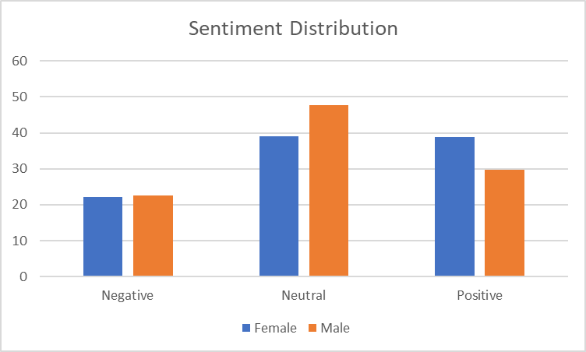

Figure 1:Sentiment Distribution (activists)

Figure 1 shows, the tones for the entire dataset, which contains different tweets. While this section narrows down the dataset and selects five keywords, which are "women," "education," "school," "university," and "girl," this helps us to extract the exact tones of their tweets. The sentiment analysis of tweets reveals exciting insights about discussing these topics. Starting with the keyword "women," male activists predominantly express a neutral sentiment, accounting for 53.76% of occurrences; see figure 2 for more detail.

However, there is also a significant presence of positive sentiment at 29.11%. Negative sentiment, although relatively lower at 17.13%, still represents a notable portion of the discussions. When it comes to the keyword "education," male activists showcase a more positive outlook, with 43.27% of tweets expressing positivity. The sentiment distribution reveals that 41.62% of tweets maintain a neutral tone, while a smaller proportion of 15.11% leans towards a negative sentiment. Regarding the keyword "school," male activists tend to exhibit a relatively balanced sentiment distribution. Approximately 47.47% of tweets maintain a neutral tone, while positive and negative sentiments stand at 27.18% and 25.35%, respectively.

This suggests that opinions and feelings towards schools are varied among male activists. In the case of the keyword "university," male activists express a predominantly neutral sentiment, accounting for 56.84% of tweets. However, there is also a notable presence of positive sentiment at 27.24%. Negative sentiment represents a smaller proportion, accounting for 15.92% of occurrences. Finally, when it comes to the keyword "girl," male activists express a combination of sentiments.

The sentiment analysis reveals that 31.07% of tweets express a positive sentiment, while 47.15% maintain a neutral tone. Negative sentiment represents a significant proportion at 21.78%, indicating that discussions surrounding girls can evoke mixed reactions among male activists. Shifting the focus to female activists, the analysis indicates that they utilize these keywords more frequently than their male counterparts. Out of a total of 34,837 occurrences, women contributed 13,615 tweets related to these topics, suggesting their openness to discussing women’s education on Twitter. Analyzing the sentiment distribution among female activists, the keyword "women" elicited a mix of sentiments. While negative sentiment accounted for 19.22% of occurrences, a larger portion of 39.61% expressed a positive sentiment, indicating a more optimistic view.

Neutral sentiment constituted the majority at 41.17%. Regarding "education," women activists showcased a higher inclination towards positivity, with 48.55% of tweets expressing a positive sentiment. Negative sentiment accounted for 20.25% of occurrences, while neutral sentiment stood at 31.19%. Similar to their male counterparts, discussions around "school" among female activists exhibited a relatively balanced sentiment distribution. Negative sentiment represented 26.05% of tweets, followed by neutral sentiment at 39.98% and positive sentiment at 33.96%.

For the keyword "university," women activists leaned towards a neutral sentiment 43.85% as well, but positive sentiment 36.51% held a considerable presence. Negative sentiment accounted for 19.64% of occurrences. Lastly, the keyword "girl" evoked a mixture of sentiments among female activists. Negative sentiment represented 23.29% of tweets, while neutral sentiment accounted for 39.66%. Positive sentiment stood at 37.04%, highlighting a relatively optimistic outlook. We can say that men are more likely to have neutral tone, while women are more likely to express positive tone regarding the five keywords.

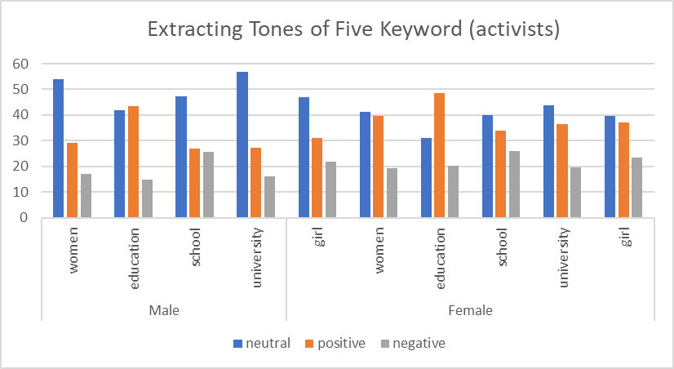

Figure 2: Extracting Tones of Five Keyword (activists)

The sentiment analysis results reveal interesting patterns in the way both male and female participants expressed their opinions.

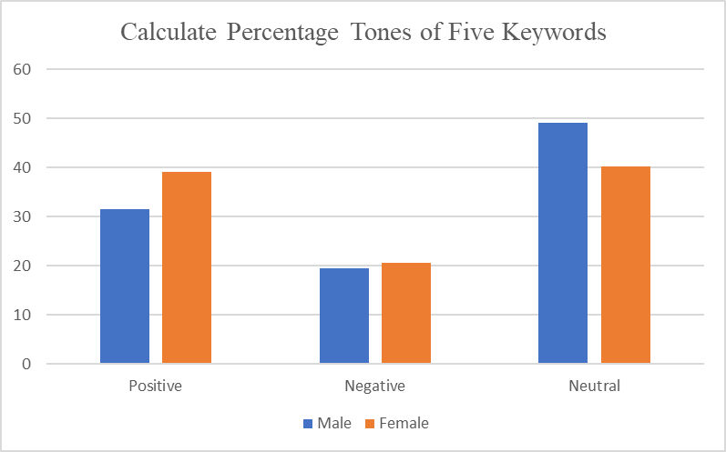

Figure 3: Calculate Percentage Tones of Five Keywords (activists)

Figure 3 shows that among male activists, 31.43% of their sentiments were positive, while 19.52% leaned towards negativity. The majority, 49.04%, expressed a neutral sentiment, indicating a balanced perspective overall. In contrast, female activists exhibited higher positivity, with 39.12% of their sentiments being positive. Similar to males, around 20.59% of their sentiments are negative. However, a slightly lower proportion, 40.28%, expressed a neutral sentiment. These findings suggest differences in how males and females express their sentiments regarding the analyzed keywords.

To completely narrow down our data, and specifically look for women’s education, we have used keyword of “women education”, this allows us to break down the data and look for those tweets which has only these two words.

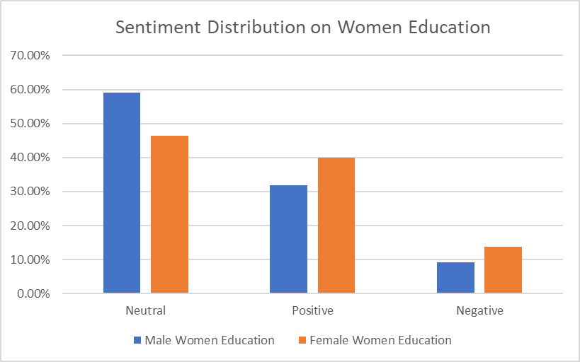

Figure 4: Sentiment Distribution on Women Education (activists)

Figure 4, reveals that, among males, the sentiment appears to be predominantly neutral, with a significant percentage of 59.09%, indicating a balanced outlook or perhaps a lack of strong emotional inclination towards women’s education. Positive sentiment follows closely behind at 31.82%, suggesting a favorable perception and support for empowering women through education. However, negative sentiment among males remains present, though comparatively lower at 9.09%, highlighting some reservations or concerns regarding this topic.

After analyzing the tones of the activists tweets, its time to identify the the different tweets among them. This helps us to understand which activists has more positive, negative and neutral tone.

|  |  |  |
| --- | --- | --- |
| Gender | T-Statistic | P-Value |
| Male | 13.59% | 6.61% |
| Female | 42.01% | 0.00% |

Table 5: Calculate Sentiment Scores for Entire Dataset (activists)

Table 8 shows the results of our study into the gender gap in tweet sentiment ratings throughout the full dataset. Although we looked at the whole dataset, we zeroed in on the differences between male and female responses. The P-value reflects the statistical significance of the difference in mean attitudes between the two groups, while the T-statistic evaluates the magnitude of that difference. The T-statistic for detecting a difference in sentiment between positive and negative tweets about men was 13.59%. This divergence is extraordinarily improbable to arise by chance, as indicated by the incredibly small P-value of 6.61%.

We found an even starker contrast between male and female tweets. The T-statistic of 42.01% is significantly different from the 0 that would show no bias in any direction. This difference is extremely noteworthy; the P-value of 0.00 further supports this conclusion. In addition, we used our keywords to conduct an analysis of educational-themed tweets. We have used the same method for our five keywords, which are “education”, “school”, “university”, “women”, “girl”, by doing this we basically compare male and female tweets through coding, see Appendix.

Table 6, revealed the T-statistic of 12.23% indicates that the sentiment score is significantly different from the neutral value of 0. The P-value of 4.97% indicates a highly significant difference. Men’s views on education, especially as it pertains to women, clearly display a sentiment that markedly deviates from neutrality, as seen by the above.

|  |  |  |
| --- | --- | --- |
| Gender | T-Statistic | P-Value |
| Male | 12.23% | 4.97% |
| Female | 28.32% | 1.69% |

Table 6: Calculate Sentiment Scores for Five Keywords (activists)

When we refer to women’s tweets, we get a significant departure from neutrality, with a t-statistic of 28.32% and an incredibly small p-value of 1.69%. This indicates that women’s sentiments about education, as expressed in their tweets, differ significantly from neutrality. These findings highlight the distinct perspectives and attitudes of male and female when discussing education.

Understanding these divergent sentiments is crucial for addressing gender-specific challenges and promoting inclusivity in educational contexts. In short, the analysis provides strong evidence of gender-related differences in sentiment expression and emphasizes the need for considering gender perspectives in educational discourse. To get solid result regarding women’s education, it’s time to only test “women education” keyword, both count as a single keyword.

|  |  |  |
| --- | --- | --- |
| Gender | T-Statistic | P-Value |
| Male | 2.59% | 0.01% |
| Female | 3.43% | 0.00% |

Table 7: Calculate Sentiment Scores for Women Education (activists)

Uncovering distinct sentiment patterns among male and female. Male’s tweets displayed a discernible shift from neutral sentiment, as evidenced by a t-statistic of 2.59% and a p-value of 0.01%. Meanwhile, female’s tweets exhibited an even more pronounced deviation, indicated by a higher t-statistic of 3.43% and a p-value of 0.00%.

These findings underscore the substantial differences in sentiment expressed by male and female when discussing women’s education. Recognizing and addressing these divergences can guide targeted approaches and foster inclusivity within educational contexts. Gender serves as a crucial factor in shaping perspectives and emotions surrounding this important topic.

The chi-square test of independence was performed separately for male and female genders. For the male gender, the test yielded a chi-square statistic of 53.38 and an extremely small p-value of 2.57e-12. Similarly, for the female gender, the chi-square statistic was 35.16, with a highly significant p-value of 2.31e-08. These results indicate a strong association between the gender of the users and the presence of tweets related to the five specified keywords. The cross-tabulation of gender and label shows that among females, 21,222 tweets were not related to the keywords, while 13,616 tweets were related. Among males, 10,934 tweets were not related to the keywords, and 6,474 tweets were related.

The significant chi-square test results suggest that the occurrence of tweets related to the specified keywords differs significantly between genders. The findings imply that there are notable differences in the engagement and discussion of the specified topics on social media platforms based on gender. Such insights can be valuable for understanding gender-specific perspectives and behaviors related to the given keywords and can aid researchers, policymakers, and educational institutions in tailoring strategies and initiatives accordingly.

## Female Activists’ Top Frequent Words

Figure 5 shows, the top frequent words of activists, which is been frequently used on their tweets. Female activists tend to focus on gender issues and the situation in Afghanistan, as seen by the prevalence of the terms "Taliban," "women," "Afghanistan," "girl," and "Afghan." Moreover, the use of terms like "people," "rights," "school," "Kabul," and "education" demonstrates their interest in broader social and educational concerns. Similar patterns arise for male activists, who tend to focus on topics like the Taliban, Afghanistan, women, and girls. They also place an emphasis on the words "education," "school," "Kabul," "Talibans," and "people," suggesting that they are participating in conversations about schools, Kabul, and the Afghan people more generally.

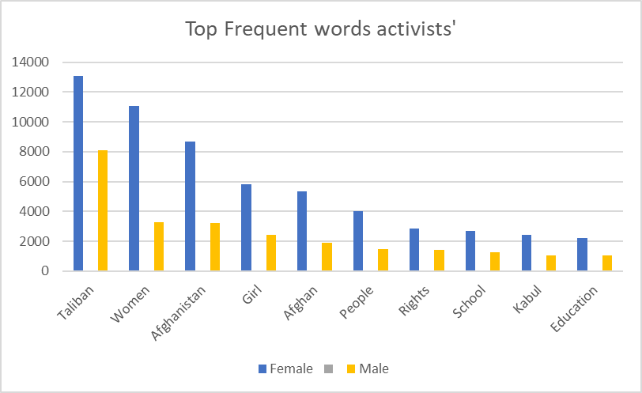

Figure 5: Female Activists Top Frequent Words

Figure 5, the word cloud for female activists reveals the main subjects they actively address. It visually represents their involvement in discussions related to the Taliban, women’s rights, Afghanistan, girls, and education. These prominent terms capture the key themes and issues that female activists passionately advocate for, emphasizing their commitment to promoting gender equality and driving positive social change.

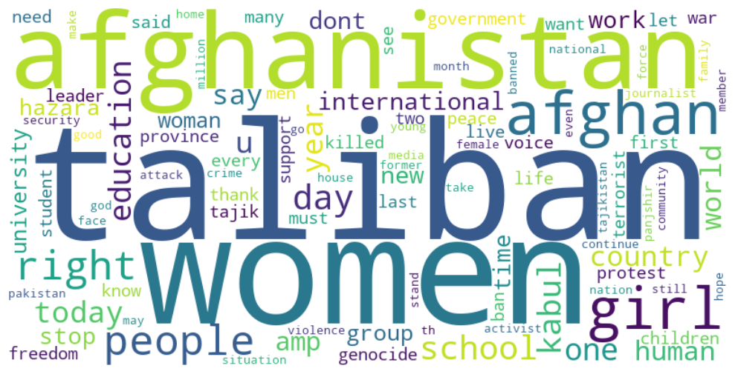

Figure 6: Female Activists Word-Cloud

Figure 7, the word cloud for male activists visually presents the key themes they are passionate about. It illustrates their active involvement in conversations related to the Taliban, Afghanistan, women, girls, and education. These prominent terms reflect the specific areas that capture the attention and commitment of male activists, highlighting their significant contributions and dedication to discussing and addressing these crucial topics. The word cloud offers a glimpse into their engagement and dedication to social issues and advocacy.

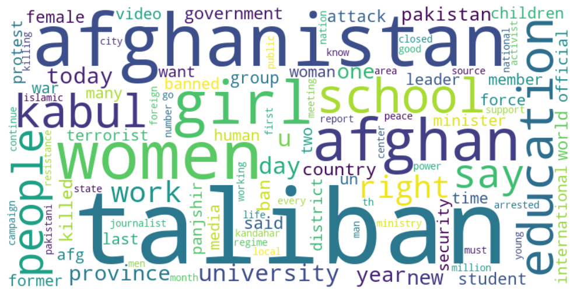

Figure 7: Male Activists Word-Cloud

We used logistic regression to explore how different groups see the importance of women’s education. We used gender as an IV, with females represented by a value of 1 and males by 0. By using algorithmic methods to combine activist data from men and women, we ensured a computational strategy throughout the investigation. The correlation between gender and women’s education is explored in fascinating detail by the logistic regression results. Women (represented by a 1) are more likely than men (represented by a 0) to be in favour of investing in women’s education, as indicated by the coefficient for the "sex" variable. This finding highlights the critical function of activists in promoting women’s education. It underscores the significance of providing women with access to education as a means of achieving gender equality and empowering them. The results of this study shed light on the work of activists to advance women’s education and highlight the need for concerted efforts to promote educational equity for all people.

Optimization terminated successfully.

Current function value: 0.666068

Iterations 4

Logit Regression Results

==============================================================================

Dep. Variable: label No. Observations: 52246

Model: Logit Df Residuals: 52244

Method: MLE Df Model: 1

Date: Thu, 01 Jun 2023 Pseudo R-squ.: 0.0002533

Time: 20:25:14 Log-Likelihood: -34799.

converged: True LL-Null: -34808.

Covariance Type: nonrobust LLR p-value: 2.681e-05

==============================================================================

coef std err z P>|z| [0.025 0.975]

------------------------------------------------------------------------------

const -0.5241 0.016 -33.420 0.000 -0.555 -0.493

sex 0.0803 0.019 4.194 0.000 0.043 0.118

==============================================================================

## Taliban and Ordinary People Perceptions

This section consists of activists both male and female, Taliban officials is only male, there is no female in the cabinet of the Taliban, and also, ordinary people, which are Afghan people does not involve in politics. Except the Taliban the other two groups both consists of male and female, but our focus is not on the gender, instead we analyze them in a group, based on their background, like “activist, people, and Taliban”. At first, we would have a look at their tweets in group, then we move forward and analyze them in dept, using keywords, “education”, “school”, “university”, “women”, “girl”, and “women education”. These keywords narrow down the dataset and analyze only those tweets which related to these certain words.

The analysis conducted focused on three distinct groups: activists, Taliban, and people. The sentiments expressed in the dataset were categorized into three categories: negative, neutral, and positive. Looking at the sentiment distribution, it is evident that the majority sentiment in all three groups is neutral. Activists have the highest count of neutral sentiments with 21,713 occurrences, followed by the people with 43,428 occurrences. The Taliban group, however, has a relatively lower count of neutral sentiments, with the exact number not specified. Moving on to positive sentiments, activists show a significant proportion, with 18,635 occurrences. People also exhibits a considerable number of positive sentiments, with 39,255 occurrences. Taliban has 34,009. Regarding negative sentiments, activists have 11,568 occurrences, while people demonstrates 22,944 occurrences. Similarly, the exact count of negative sentiments for the Taliban group is 16,204.

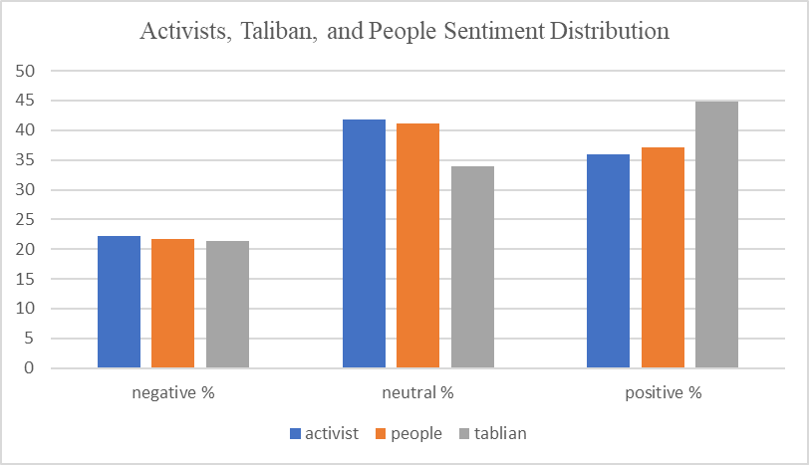

Figure 8: Sentiment Distribution of

To gain further insights, the percentages of each sentiment category for the different groups can be analyzed. For the activist group, negative sentiments represent approximately 22.28% of the total sentiments, while neutral sentiments make up the largest proportion at 41.82%. Positive sentiments also have a substantial presence, accounting for about 35.89% of the sentiments expressed by activists. For the people, the distribution of sentiments is somewhat similar. Negative sentiments comprise around 21.72%, while neutral sentiments constitute the highest percentage at 41.11%.

Positive sentiments make up approximately 37.16% of the sentiments expressed by the people. In the case of the Taliban group, negative sentiments account for roughly 21.33% of the sentiments expressed, while neutral sentiments make up approximately 33.90%. Notably, the Taliban group shows a higher proportion of positive sentiments, with around 44.77%. Notably, the provided information covers a wide variety of topics outside only women’s education, and this study takes a look at how sentiments are spread across the board. Negative, neutral, and positive sentiment categories capture the range of opinions and feelings expressed by participants in the dataset. In the next section we break down our dataset related to women’s education through five different keywords which previously mentioned.

In the sentiment distribution figure 9 provided, we can observe that the sentiment values for the Taliban group are represented as "NaN" (Not a Number). This occurrence raises questions and requires investigation to understand the underlying reasons. One potential explanation is the insufficient availability of relevant data specifically pertaining to the Taliban group and the given keywords

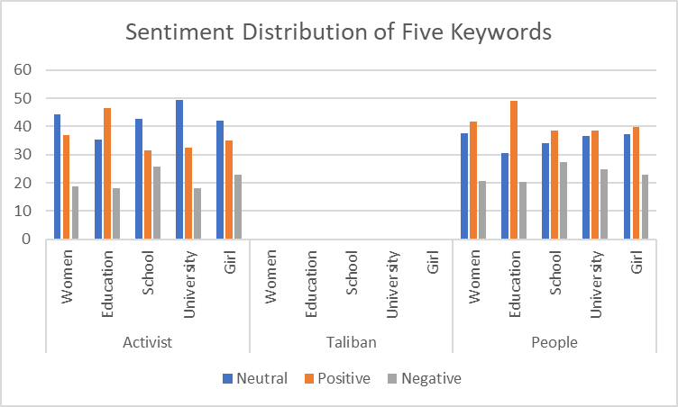

Figure 9: Sentiment Distribution of five Keywords

Sentiment analysis algorithms rely on a substantial amount of data to accurately assess sentiment, and the absence of an adequate sample size for the Taliban group could lead to missing sentiment values. It is also possible that during the data filtering or preprocessing stages, the criteria applied to extract tweets related to the Taliban group inadvertently resulted in the exclusion of relevant tweets for those specific keywords. Furthermore, the sentiment expressed in tweets associated with the Taliban group might exhibit unique patterns or intricate nuances that challenge sentiment analysis algorithms to assign sentiment scores accurately.

When examining the sentiment distribution among activists, we observed varying opinions on the issue of women’s education. For the keyword "women," the sentiment distribution showed diverse views. Approximately 44.42% of the tweets expressed a neutral sentiment, indicating a lack of clear stance or mixed opinions. On the positive side, 36.91% of the tweets supported women’s issues, emphasizing the importance of education and empowerment. However, it is worth noting that around 18.68% of the tweets reflected a negative sentiment and expressed reservations or opposition towards women’s education.

Moving on to the keyword "education," we found that among activists, 35.43% of the tweets had a positive sentiment, highlighting the value and significance of education for women. Conversely, 18.16% of the tweets expressed a negative sentiment, suggesting concerns or objections regarding women’s access to education. Notably, 46.41% of the tweets remained neutral, indicating a lack of strong sentiment or a balanced perspective among activists. Regarding the keyword "school," the sentiment distribution showed a similar pattern. Activists expressed a mix of sentiments, with 42.67% of the tweets being neutral, 31.53% positive, and 25.80% negative. This suggests that while a significant proportion of activists support the idea of women attending school, there are also concerns or criticisms expressed by a notable portion of the community.

For the keyword "university," the sentiment distribution among activists revealed that 49.43% of the tweets had a neutral sentiment, indicating a lack of a clear stance. However, 32.52% of the tweets were positive, demonstrating support for women pursuing education. Around 18.04% of the tweets displayed a negative sentiment, reflecting reservations or objections towards women’s participation in university education. Lastly, focusing on the keyword "girl," the sentiment distribution among activists showcased a similar trend to the previous keywords. Approximately 42.06% of the tweets had a neutral sentiment, while 35.13% expressed a positive sentiment, emphasizing the significance of supporting girls’ education. Around 22.81% of the tweets displayed a negative sentiment, indicating concerns or criticisms about girls’ education access.

We can observe notable differences when comparing the sentiment distribution between the people, and activist groups. The activist shows higher support for women’s education, with higher percentages in the positive sentiment category than the people. The activist also demonstrates a relatively lower percentage in the negative sentiment category. Conversely, the people group has a higher percentage in the negative sentiment category, suggesting a comparatively lower level of support or more critical views regarding women’s education. These differences highlight varying perspectives and levels of support within the two groups, emphasizing the distinct roles and attitudes of activists and the general population in advocating for women’s education.

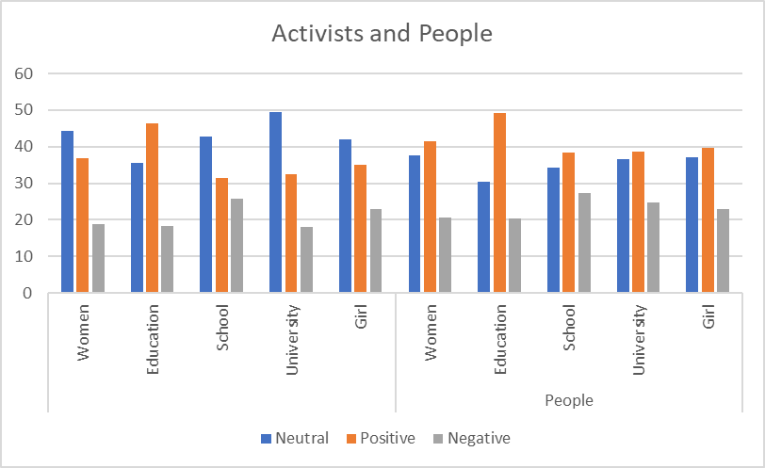

Figure 10: Activists and People

Figure 10 show, compares those keywords between activists and people. We can see that activists are more likely to be positive compared to people.

|  |  |  |  |  |  |  |  |  |  |  |  |  |  |  |  |
| --- | --- | --- | --- | --- | --- | --- | --- | --- | --- | --- | --- | --- | --- | --- | --- |
| Activist | | | | | | Taliban | | | | | People | | | | |
| Sentiment | Women | Education | School | University | Girl | Women | Education | School | University | Girl | Women | Education | School | University | Girl |
| Neutral | 44.42 | 35.43 | 42.67 | 49.43 | 42.06 | Nan | Nan | Nan | Nan | Nan | 37.72 | 30.45 | 34.17 | 36.69 | 37.20 |
| Positive | 36.91 | 46.41 | 31.53 | 32.52 | 35.13 | Nan | Nan | Nan | Nan | Nan | 41.59 | 49.16 | 38.45 | 38.59 | 39.75 |
| Negative | 18.68 | 18.16 | 25.80 | 18.04 | 22.81 | Nan | Nan | Nan | Nan | Nan | 20.70 | 20.39 | 27.37 | 24.72 | 23.05 |

Table 8: Sentiment Analysis of Tweets Containing the Keyword

In Table 14, we can observe the percentage breakdown of each keyword, highlighting an unfortunate absence of data for the Taliban group. There are a couple of potential explanations for this absence. It could be that the Taliban either refrains from tweeting about these specific keywords or their involvement in discussions related to women, education, school, university, and girl is minimal, resulting in negligible representation in the collected data. This underscores the significance of the data obtained from the other two groups, providing valuable insights into their perspectives.

|  |
| --- |
| Tweets Related to Keywords |
| jobs allocated women educational sector today announced ministry education jobs teachers administrative staff male female states herat farah ghor badghis nangarhar laghman kunar nuristan |
| many years uzbekistan hijab allowed women educational institutions |
| public private universities throughout country open men women education process extended percent remaining parts country thousands women education higher education public health id passport offices airports police media |

Table 9: Tweets Related to five Keywords

To narrow down our data and focus on keyword “women education” only, we found a number of noteworthy patterns emerge. We first put our attention to the Taliban group, unfortunately, the sentiment distribution data is not available NaN (0). This lack of information hinders our understanding of the Taliban’s stance on women’s education specifically. It could imply that they do not engage in discussions or tweets about women’s education, or their stance is not reflected in the dataset. Again, you can take table 14, the best tweet related to education on their dataset.

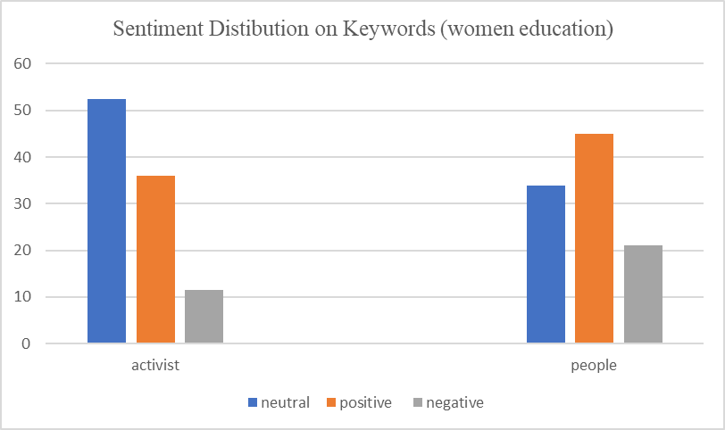

Figure 11: Sentiment Distibution on Keywords (women education)

Considering the sentiment distribution among people, it is evident that a significant proportion of tweets, 33.94%, express a neutral sentiment. This suggests diverse opinions and perspectives among the general public regarding women’s education. On the positive side, 44.95% demonstrate a supportive sentiment towards women’s education, indicating a widespread belief in the importance of empowering women through educational opportunities. Conversely, 21.1% of the tweets are negative, highlighting concerns or reservations people may have regarding various aspects of women’s education.

Based on the analysis of the sentiment distribution on the specific keyword "women education," activists show a mixed sentiment with a notable emphasis on support and advocacy. However, the lack of available data on the Taliban group limits our understanding of their stance. The general population’s sentiment distribution reveals diverse opinions, with a significant portion expressing support for women’s education while acknowledging some negative sentiments. These findings shed light on the complexities and varying perspectives surrounding women’s education within different groups, underscoring the need for further exploration and dialogue on this crucial topic.

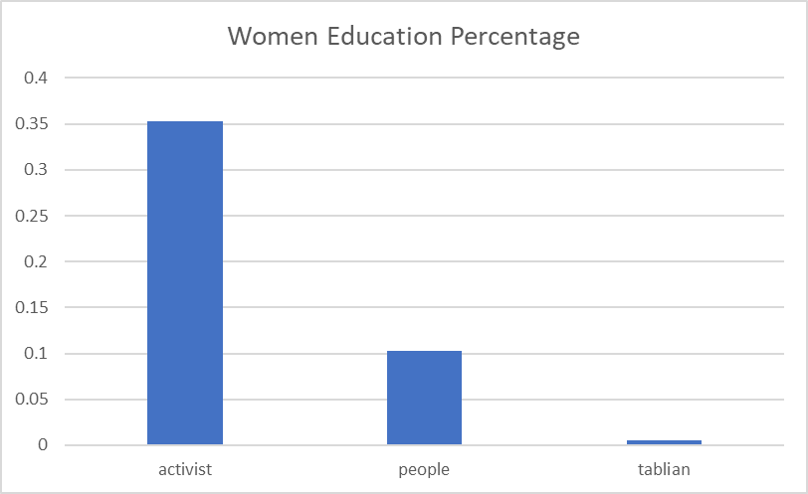

Figure 12: Women Education Percentage

The analysis reveals that the keyword "women education" has varying percentages among the different groups. Activists have the highest percentage, with 0.352492% of their tweets mentioning this keyword, followed by people with 0.103193%. On the other hand, the Taliban group has the smallest percentage of 0.005265%, which is why it does not appear in the calculations. In terms of the total number of tweets mentioning the keywords "women education," activists have 183 such tweets, while people have 109, and the Taliban only has 4. These findings indicate that activists engage more frequently in discussions related to women’s education, followed by people, while the Taliban group demonstrates the least involved in conversations about this topic.

## Analyzing the Frequency of Keywords Regarding Women’s Education

The figure 12 provides valuable insights regarding our keywords, namely "women," "education," "school," "university," and "girl." It illustrates the frequency of these keywords’ usage by different groups over the course of each year. Based on the figure, we can observe that activists have consistently used these keywords more frequently in their tweets, particularly between October 2022 and January 2023. These findings suggest that the activist group has shown higher engagement and emphasis on these topics during those specific time frames.

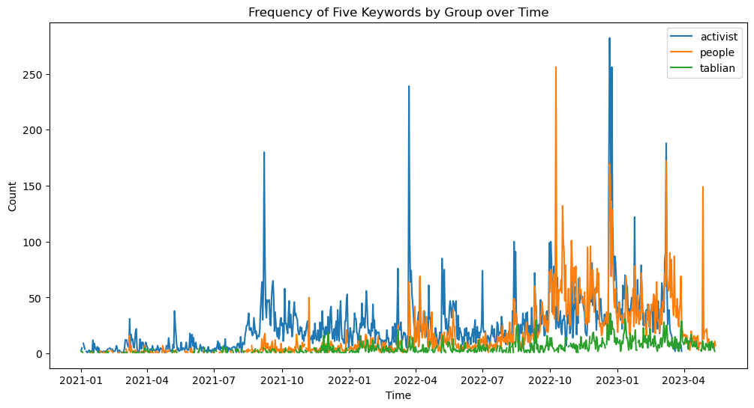

Figure 13: Frequency of Five Keywords by Group over Time

Additionally, the analysis reveals that the people has noticeably utilized the mentioned keywords. This indicates that people are actively engaged in discussions related to education and express support for women’s rights and equality in education. On the other hand, the Taliban has exhibited a considerably lower frequency of tweets containing these keywords. This suggests that the Taliban group may not prioritize or demonstrate concern for women’s education based on their limited usage of these keywords.

## Taliban Top Frequent Words

The Taliban’s most frequently used terms reveal their point of view. Words like "Afghanistan," "people," and "Islamic" reveal their connection with the region, their religion, and their political leanings, respectively. They appear to be leading towards an Islamic state, as terms like "minister," "country," and "emirate" all point that way. The words "ministry," "god," "said," and "foreign" all allude to their diplomatic and theological concerns. These reoccurring expressions shed light on the Taliban’s overarching goals and ideas.

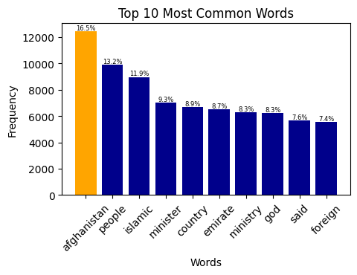

Figure 14: Taliban Top Frequent Words

The word cloud for the Taliban reveals key themes and priorities. It prominently includes words such as "Afghanistan," "people," and "Islamic," highlighting their close association with the country and their religious ideology. Terms like "minister," "country," and "emirate" suggest their involvement in governance and their pursuit of an Islamic state. This word cloud offers a concise glimpse into the Taliban’s central focus and core values.

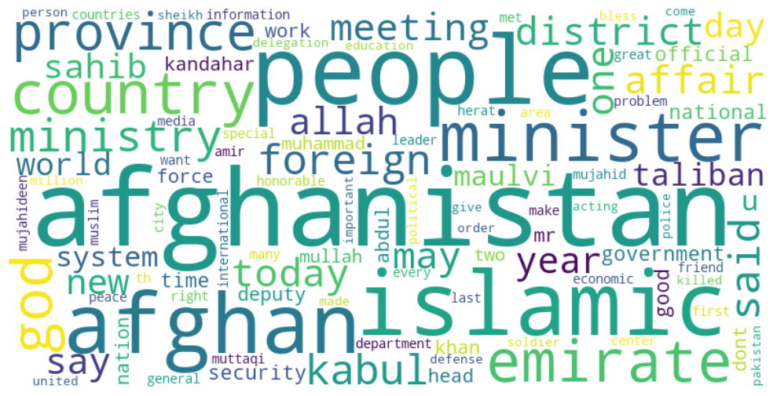

Figure 15: Taliban Word-Cloud

## Female Ordinary People Top Frequent Words

Ordinary women’s top 10 words represent their worries and activism. "Hazara," "genocide," and "stop" show their awareness and activism. "Afghanistan," "women," and "people" demonstrate their national identity. "Taliban" shows their resistance to the gang, while "girl" underlines their empowerment of young women. These remarks reveal the social and political priorities of regular women.

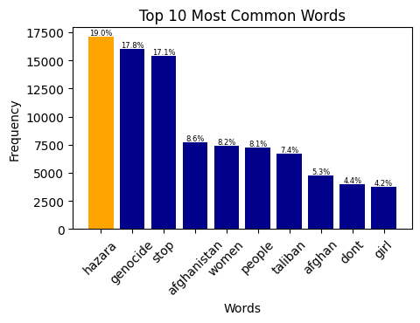

Figure 16: Female Ordinary People Top Frequent Words

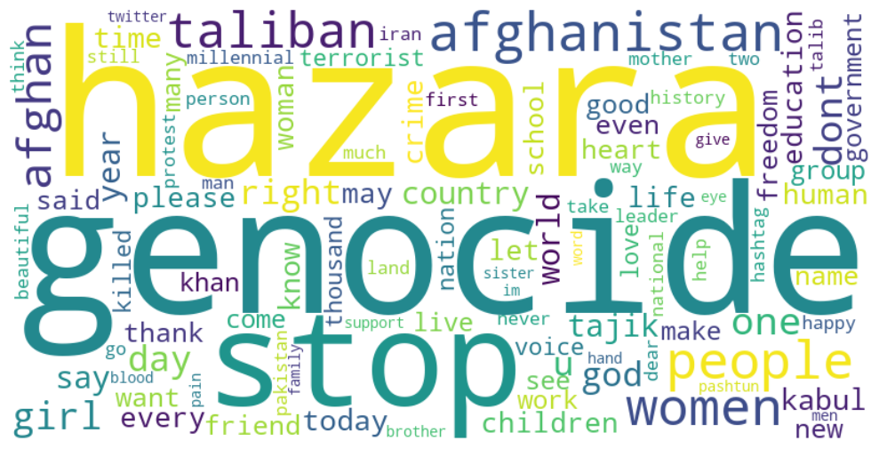

Figure 17: Female Ordinary Word-Cloud

Male ordinary people, word cloud expresses their concerns, about Afghanistan and the Taliban. "Afghanistan," "Taliban," and "people" show their focus on the country’s predicament and its impact on Afghans. "Hazara," "genocide," and "Pakistan" indicate their grasp of regional affairs. "Stop," "country," and "one" emphasize their patriotism, action, and individuality. The word cloud the most pressing issues and areas of interest, including Afghanistan, the Taliban, and the Hazara people. This shows that they care about ending genocide, Pakistan, and violence. The cloud symbolizes the people’s love of their homeland along with their dedication to maintaining tranquility there.

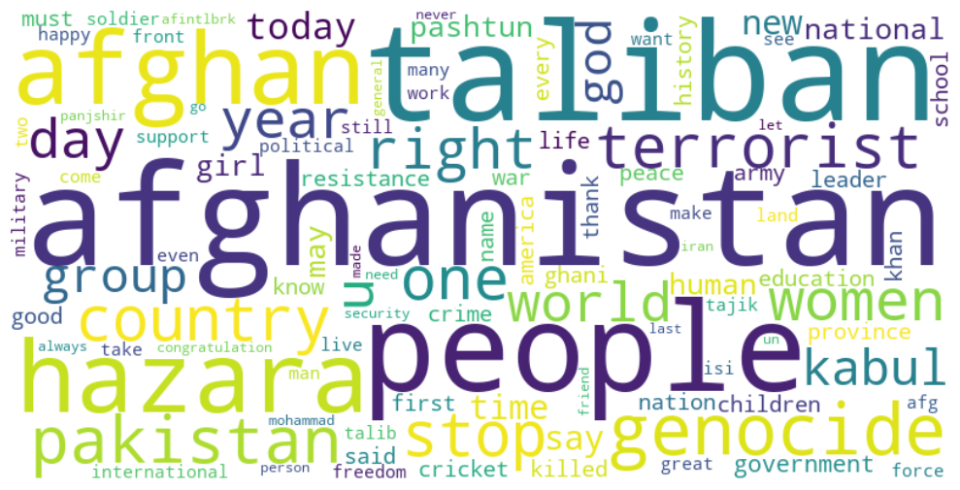

Figure 18: Male Ordinary Word-Cloud

# CHAPTER V : DISCUSSION

The discussion revolves around the perspectives of activists, the Taliban, and ordinary Afghan people regarding women’s education. Activists, driven by feminist theories and ideologies, advocate for women’s education as a fundamental right and a pathway to empowerment. They believe education is pivotal in challenging societal norms, breaking free from oppressive systems, and fostering social change. Activists view education as a means for women to shape their communities and contribute to gender equality actively.

On the other hand, the Taliban’s theoretical stance on women’s education starkly contrasts with that of activists. Rooted in religious fundamentalism and traditional gender roles, the Taliban perceives women’s education as threatening their established order. They view education for women as challenging patriarchal structures and seek to maintain oppressive systems by imposing severe limitations on women’s access to education. The Taliban’s reinforces traditional gender norms and restricts women’s opportunities for empowerment through education.

The perspectives of ordinary Afghan people vary, influenced by their education, religious beliefs, and cultural backgrounds. Some individuals align with the ideals put forth by activists, recognizing the transformative power of education and the importance of equal opportunities for women. They acknowledge that education is crucial in improving women’s lives and advancing gender equality. Others, however, may hold reservations or even oppose women’s education due to adherence to societal norms and traditional values. These individuals may subscribe to a theoretical that reinforces gender roles and inhibits progress in women’s education.

The discussion highlights the contrasting views surrounding women’s education in this theoretical landscape. Activists, driven by feminist theories, emphasize the importance of education as a tool for emancipation, while the Taliban's perspective is rooted in religious fundamentalism and the preservation of traditional gender roles. Ordinary Afghan people exhibit a range of theoretical perspectives shaped by various factors, contributing to the discourse’s complexity.

It is essential to consider when examining the support for women’s education among activists, the Taliban, and ordinary Afghan people. The theoretical perspectives influence each group’s actions, beliefs, and strategies. Activists strive to remove barriers and advocate for women’s educational access, while the Taliban seeks to maintain their established order by suppressing women’s education. Ordinary Afghan people’s theoretical stances are shaped by their unique experiences, education levels, religious beliefs, and cultural values, which further contribute to the diversity of opinions regarding women’s education.

CHAPTER VII: CONCLUSION

In conclusion, the discussion on women's education in Afghanistan reveals the contrasting viewpoints and motivations of activists, the Taliban, and ordinary Afghan people. Activists emphasize the importance of education as a fundamental right and a catalyst for empowerment, recognizing its ability to challenge societal norms, break oppressive systems, and contribute to communities. The Taliban, rooted in religious fundamentalism and traditional gender roles, perceives women's education as a threat to their established order, imposing severe limitations on access and hindering progress towards gender equality.

The perspectives of ordinary Afghan people vary, influenced by factors such as education, religious beliefs, and cultural backgrounds. While some individuals align with activist ideals, advocating for equal opportunities for women, others may hold reservations or oppose women's education due to adherence to societal norms and traditional values. This diversity of perspectives contributes to the complexity of the discourse surrounding women's education in Afghanistan.

The hypotheses proposed in this discussion provide expectations based on each group's ideologies and prior behavior. Hypothesis 1 suggests that the Taliban’s views on women’s education will be significantly more restrictive and opposed than activists and ordinary Afghan people. This aligns with the Taliban's history of imposing limitations on women's education and work during their rule in Afghanistan. Hypothesis 2 proposes that activists are more likely to demonstrate higher support for women's education than the Taliban and ordinary Afghan people. Activists, driven by the belief in education as a tool for empowerment and social change, view it as vital for women's progress. Hypothesis 3 suggests that female activists are more likely to hold stronger sentiments in supporting women's education than male activists, reflecting a deeper understanding of women's challenges.

This discussion sheds light on the complex dynamics surrounding the education of women in Afghanistan, highlighting its importance in challenging gender inequality, empowering women, and driving social progress. Activists play a vital role in advocating for women's access to education and breaking down barriers. They firmly believe that education is a basic right for everyone and a crucial tool for building a more equitable and fair society. However, the discussion also brings to the forefront the divergent position of the Taliban, which aims to uphold traditional gender roles and restrict women's education. The Taliban's viewpoint is based on a fundamentalist religious ideology. This clash of ideologies between activists and the Taliban forms a significant part of the struggle for women's education in Afghanistan.

Moreover, ordinary Afghan people’s diverse perspectives reflect Afghan society’s intricacies. Factors like education, religious beliefs, and cultural values shape individuals' opinions on women’s education. While some individuals support equal educational opportunities for women, others adhere to societal norms and traditional values that limit women’s access. This diversity underscores the need for nuanced approaches to promote women’s education and engage with various segments of Afghan society.

In conclusion, this discussion deepens our understanding of the motivations and views driving support for women’s education in Afghanistan. Activists advocate for education as a fundamental right and a means of empowering women. Conversely, the Taliban adheres to an ideology restricting women’s education and reinforcing traditional gender roles. Ordinary Afghan people exhibit a range of perspectives influenced by their education, religious beliefs, and cultural backgrounds. Recognizing and addressing these dynamics is essential in formulating strategies and policies that advance women’s education and strive for gender equality in Afghanistan.

# References

Anderson, C. L., Reynolds, T. W., Biscaye, P., Patwardhan, V., & Schmidt, C. (2021). Economic Benefits of Empowering Women in Agriculture: Assumptions and Evidence. *The Journal of Development Studies 57*, 200.

Bank, B. J. (2007). *Gender and Education: an Encyclopedia, Volumes I & II.* 88 Post Road West, Westport, CT 06881: Praeger.

Domagoj Margan, A. M. (2015). LaNCoA: A Python Toolkit for Language Networks Construction and Analysis. *In 2015 38th International Convention on Information and Communication Technology, Electronics and Microelectronics*.

El Barachi, M., AlKhatib, M., Mathew, S., & Oroumchian, F. (2021). A novel sentiment analysis framework for monitoring the evolving public opinion in real-time: Case study on climate change. *Journal of Cleaner Production*, 1.

Evans, H. K., & Clark, J. (2015). “You Tweet Like a Girl!”: How Female Candidates Campaign on Twitter. *American Politics Research*, 10.

Fluri, J. L. (2009). Geopolitics of gender and violence from below. *Political Geography*, 260.

Franks, M. A. (2003). Obscene Undersides: Women and Evil between the Taliban and the United States. *Wiley on behalf of Hypatia, Inc*.

Inayatullah, S. (2022). Women’s Education in Afghanistan Disparities in Education Under the Taliban affecting Women’s Capabilities Development. *Malmo university*.

Johnson, L. (2004). A Generation of Women Activists: African American Female Educators in Harlem, 1930-1950. *Jstor*.

Karamouzas, D., Mademlis, I., & Pitas, I. (2022). Public opinion monitoring through collective semantic analysis of tweets. *Social Network Analysis and Mining*, 1.

Karlsson, P., & Mansory, A. (2008). Islamic and Modern Education in Afghanistan - Conflictual or Complementary? *Institute of International Education Stockholm University*.

Kihlstrom, J. F., & Cantor, N. (2000). Social Intelligence. *Cambridge, England: Cambridge University Press*.

Kitzie, V., & Ghosh, D. (2016). #Criming and #Alive: Network and content analysis of two sides of a story on twitter. *American Journal of Political Science*, 2.

Klenk, R. M. (2010). *Educating Activists Development and Gender in the Making of Modern Gandhians.* Estover Road, Plymouth PL6 7PY, United Kingdom: Lexington Books.

Lewis, D., & Burke, C. J. (1949). Categorical Data and Chi-Square Tests. *American Journal of Political Science*.

Liu, B. (2015). *Sentiment Analysis: Mining Opinions, Sentiments, and Emotions.* United States of America: Cambridge University Press.

Lorber, J. (2001). *Gender Inequality: Feminist Theories and Politics.* Los Angeles, California: Claude Teweles.

Luguetti, C., & Oliver, K. L. (2020). A transformative learning journey of a teacher educator in enacting an activist approach in Physical Education Teacher Education. *American Journal of Political Science*.

Lyytikäinen, L. (2013). Gendered and classed activist identity in the Russian oppositional youth movement. *American Journal of Political Science*.

Mashwani, H. U. (2017). Female Education in Afghanistan: Opportunities and Challenges. *International Journal for Innovative Research in Multidisciplinary Field*.

Mayring, P. (2004). Qualitative Content Analysis. *A companion to qualitative research*.

McGregor, S. L. (2015). Framing consumer education conceptual innovations as consumer activism. *American Journal of Political Science*.

Nussbaum, M. C. (2004). Women’s Education: A Global Challenge. *The University of Chicago Press*.

Orfan, S. N. (2021). Political participation of Afghan Youths on Facebook: A case study of Northeastern Afghanistan. *Cogent Social Sciences*.

Parson, L. (2020). Researching Gender and Higher Education. *American Journal of Political Science*, 515.

Pedregosa, F. (2011). Scikit-learn: Machine Learning in Python. *Journal of Machine Learning Research*, 2826.

Plutzer, L. A. (1993). Contextual Determinants of Feminist Attitudes: National and Subnational Influences in Western Europe. *American Political Science Association*, 149.

Rene, R. (2010). *A Survey of the Afghan People.* AINA Media, Kabul: The Asia Foundation.

Rieger, T. A. (2019). A survey of the Afghan people: Afghanistan in 2019. *The Asia Foundation*.

Scott, R., & Kosslyn. (2015). Content Analysis. *American Journal of Political Science*, 9.

Skaine, R. (2002). *The Women of Afghanistan Under the Taliban.* Jefferson, North Carolina: McFarland & Company, Inc.

Telesetskyt, A. (1998). In the Shadows and Behind the Veil: Women in Afghanistan Under Taliban Rule. 1.

Weiner, G. (1986). Feminist Education and Equal Opportunities: Unity or Discord. *British Journal of Sociology of Education , 1986, Vol. 7, No. 3 (1986), pp. 265- 274*.

Welzel, C., & Inglehart, R. (2008). The Role of Ordinary People in Democratization. *Journal of democracy*.

Women, U. (2022). Women's rights in Afghanistan, one year after the Taliban taken-over.

Yousaf, F., & Jabarkhail, M. (2021). Afghanistan’s future under the Taliban regime: engagement or isolation? *Routledge*.

# Appendix

1. import tweepy

2. import pandas as pd

3. consumer_key = ‘your_consumer_key’

4. consumer_secret = ‘your_consumer_secret’

5. access_token = ‘your_access_token’

6. access_token_secret = ‘your_access_token_secret’

7. auth = tweepy.OAuthHandler(consumer_key, consumer_secret)

8. auth.set_access_token(access_token, access_token_secret)

9. api = tweepy.API(auth)

10. username = ‘twitter_username’

11. tweets = api.user_timeline(screen_name=username, count=100)

12. tweets_list = []

13. for tweet in tweets:

14. tweets_list.append({

15. ‘created_at’: tweet.created_at,

16. ‘text’: tweet.text,

17. ‘retweets’: tweet.retweet_count,

18. ‘favorites’: tweet.favorite_count

19. })

20. df = pd.DataFrame(tweets_list)

21. print(df.head())

Table 10. Fetch tweets by username

1. import pandas as pd

2. tweets_df = pd.read_excel(‘../data_processed/complete.xlsx’)

3. tweets_df = tweets_df.dropna()

4. tweets_df[‘text’] = tweets_df[‘text’].str.lower()

5. keywords = ["women", "education", "schools", "study", "learn", "right", "ban", "people",

6. "afghan", "educated", "girls", "female", "protest", "pashtun", "tajik", "uzbek", "hazara",

7. "rights", "prohibit", "patriarch", "close schools", "close universities", "university", "man"]

8. matched_tweets = {}

9. for keyword in keywords:

10. tweets_df[‘text’] = tweets_df[‘text’].fillna(‘‘)

11. matched_tweets[keyword] = tweets_df[tweets_df[‘text’].str.contains(keyword, case=False)]

12.

13. for keyword, df in matched_tweets.items():

14. print(f"{keyword}: {len(df)}")

15. for keyword, df in matched_tweets.items():

16. df.to_excel(f"../data_processed/{keyword}_matched_tweets.xlsx", index=False)

Table 11. Find related data by keywords

1. def remove_usernames_links(tweet):

2. tweet = re.sub("@[^\s]+","",str(tweet))

3. tweet = re.sub("http[^\s]+","",str(tweet))

4. return tweet

5. df = df.replace(r"\n"," ", regex=True)

6. df["text"] = df["text"].apply(remove_usernames_links)

Table 12. Remove URL, and mention

1. from collections import Counter

2. hashtags = []

3. for row in df[‘text’]:

4.     hashtags.extend([tag.strip("#") for tag in row.split() if tag.startswith("#")])

5. counts = Counter(hashtags)

6. top_tags = counts.most_common(10)  # modify topn parameter here

7. fig, ax = plt.subplots(figsize=(12, 8))

8. ax.bar([tag[0] for tag in top_tags], [len(tag[0]) for tag in top_tags])

9. ax.set_title("Top 50 Hashtags with Lengths")

10. ax.set_xlabel("Hashtag")

11. ax.set_ylabel("Length")

12. plt.xticks(rotation=90)

13. plt.show()

Table 13. Top 10 Trends

1. import pandas as pd

2. import re

3. pattern = r’#\w+’

4. df[‘hashtags’] = df[‘text’].str.extractall(pattern)[0].values

5. print(df)

Table 14. Remove Hashtags

1. import pandas as pd

2. contraction_map={

3. "ain’t": "is not",

4. "aren’t": "are not",

5. "can’t": "cannot",

6. }

7. def expand_contractions(text):

8. pattern = re.compile(‘({})’.format(‘|’.join(contraction_map.keys())), flags=re.IGNORECASE|re.DOTALL)

9. def replace(match):

10. return contraction_map[match.group(0).lower()]

11. return pattern.sub(replace, text)

12. text_cols = data.select_dtypes(include=[object]).columns

13. data[‘text’] = data[‘text’].apply(lambda x:expand_contractions(str(x)))

14. data.head(5)

Table 15. Expand Contractions

1. import re

2. sample_string = ‘This is a sample string with ASCII characters: !@#$%^&*()_+={}[]|\:;"<>,.?/`~’

3. clean_string = re.sub(r’[^\x00-\x7F]+’, ‘‘, sample_string)

4. print(‘Original string:’, sample_string)

5. print(‘Cleaned string:’, clean_string)

Table 16.Remove ASCII Characters

1. def whitespace(columns_name, text):

2.     data[columns_name] = data[columns_name].replace(‘‘, ‘‘, regex=True) #remove empty string

3.     data[columns_name] = data[columns_name].str.strip() #remove whitespace

4. whitespace(‘name’,data)

5. whitespace(‘text’,data)

Table 17. Remove Whitespace

1. df.dropna(subset=[‘text’], inplace=True)

2. df.dropna(inplace=True)

3. df.drop_duplicates(subset=[‘text’], inplace=True)

4. df[[‘text’]].sample(5)

Table 18. Drop Null Values

1. import string

2. def remove_punctuations(text):

3.     for punctuation in string.punctuation:

4.         text = text.replace(punctuation, ‘‘)

5.     return text

6. df[‘text’] = df[‘text’].apply(remove_punctuations)

Table 19. Remove Punctuations

1. ct = pd.crosstab([df[‘ethnic’], df[‘gender’]], df[‘label’], normalize=‘index’)

2. print(ct)

Table 20. Contingency Code

1. from sklearn.feature_extraction.text import CountVectorizer

2. from sklearn.linear_model import LogisticRegression

3. import numpy as np

4. vectorizer = CountVectorizer(stop_words=stopwords.words(‘english’))

5. X_train_vectorized = vectorizer.fit_transform(X_train)

6. unwanted_words = [‘afghanistan’, ‘taliban’, ‘afghan’, ‘kabul’]

7. for word in unwanted_words:

8. try:

9. idx = vectorizer.vocabulary_[word]

10. del vectorizer.vocabulary_[word]

11. vectorizer._validate_vocabulary()

12. X_train_vectorized = X_train_vectorized[:, np.arange(X_train_vectorized.shape[1]) != idx]

13. except KeyError:

14. pass

15. X_train_vectorized = vectorizer.fit_transform(X_train)

16. lr = LogisticRegression()

17. lr.fit(X_train_vectorized, y_train)

Table 21. Transforming Textual to numeric

1. from sklearn.metrics import classification_report

2. y_pred = lr.predict(X_test_vectorized)

3. print(classification_report(y_test, y_pred))

Table 22. Evaluate Performance

1. def label_tweets(text):

2.     keywords = ['education', 'school', 'university', 'women', 'girl']

3.     for keyword in keywords:

4.         if keyword in text.lower():

5.             return 1

6.     return 0

7. df = df.copy()

8. df['label'] = df['text'].apply(label_tweets

Table 23: Labeling Data

1. x = df['text']

2. sentiment_labels = []

3. sentiment_scores = []

4. for tweet in x:

5.     # Create a TextBlob object

6.     blob = TextBlob(tweet)

7.     # Get the sentiment polarity (-1 to 1)

8.     polarity = blob.sentiment.polarity

9.     if polarity > 0:

10.         sentiment = 'positive'

11.     elif polarity < 0:

12.         sentiment = 'negative'

13.     else:

14.         sentiment = 'neutral'

15.

16.     sentiment_labels.append(sentiment)

17.     sentiment_scores.append(polarity)

18. # Add the sentiment labels and scores as new columns in the DataFrame

19. df['sentiment'] = sentiment_labels

20. df['sentiment_score'] = sentiment_scores

21.

Table 24: Sentiment Analysis

1. # Define custom colors for sentiment categories

2. colors = {'negative': 'red', 'neutral': 'blue', 'positive': 'orange'}

3.

4. # Calculate sentiment counts

5. sentiment_counts = df['sentiment'].value_counts()

6.

7. # Plot the sentiment counts with custom colors

8. plt.figure(figsize=(8, 6))

9. sentiment_counts.plot(kind='bar', color=[colors.get(x, 'gray') for x in sentiment_counts.index])

10. plt.xlabel('Sentiment Category')

11. plt.ylabel('Count')

12. plt.xticks(rotation=0)

13. plt.title('Sentiment Distribution')

14. plt.show()

15.

16. # Calculate total counts

17. total_counts = sentiment_counts['positive'] + sentiment_counts['negative']

18. print("Sentiment Distribution:", total_counts)

Table 25: Sentiment Distribution

1. women_positive_count = df[(df['gender'] == 'male') & (df['sentiment'] == 'positive')].shape[0]

2. women_total_count = df[df['gender'] == 'male'].shape[0]

3. women_positive_percentage = (women_positive_count / women_total_count) * 100

4. # Print the results

5. print("Positive tweets from taliban:", women_positive_count, "(", women_positive_percentage, "%)")

Table 26: Calculate Positive Tweets

1. coding_scheme = {

2. 'women': ['women', 'woman', 'female', 'feminine', 'girl', 'lady'],

3. 'education': ['education', 'educational', 'learning', 'academics', 'knowledge'],

4. 'school': ['school', 'classroom', 'teacher', 'students', 'curriculum'],

5. 'university': ['university', 'college', 'higher education', 'academia', 'campus'],

6. 'access': ['access', 'opportunity', 'enrollment', 'attendance', 'entry'],

7. 'quality': ['quality', 'standard', 'curriculum', 'teaching', 'learning'],

8. 'benefits': ['benefit', 'advantage', 'improvement', 'progress'],

9. 'barriers': ['barrier', 'restriction', 'obstacle', 'challenge', 'difficulty'],

10. 'empowerment': ['empower', 'empowering', 'confidence', 'self-esteem', 'agency'],

11. 'gender': ['gender', 'discriminatioan', 'inequality', 'feminism', 'patriarchy']

12. }

13.

14. # Define a function to apply the coding scheme to each tweet

15. def apply_coding_scheme(text):

16.     codes = []

17.     for code, keywords in coding_scheme.items():

18.         for keyword in keywords:

19.             if keyword in text.lower():

20.                 codes.append(code)

21.     return codes

22.

23. # Apply the coding scheme to the text column and create a new column for the codes

24. df_edu['codes'] = df_edu['text'].apply(apply_coding_scheme)

25.

Table 27: Code Scheme

1. from nltk.sentiment import SentimentIntensityAnalyzer

2. import nltk

3. # Initialize the sentiment analyzer

4. sid = SentimentIntensityAnalyzer()

5. # Loop through each keyword and calculate the sentiment of tweets containing that keyword

6. for keyword in ['women', 'education', 'school', 'university', 'girl']:

7.     keyword_tweets = df_edu[df_edu['text'].str.contains(keyword)].copy()

8.     keyword_tweets.loc[:, 'sentiment_score'] = keyword_tweets['text'].apply(lambda x: sid.polarity_scores(x)['compound'])

9.     print(f"Sentiment analysis of tweets containing the keyword '{keyword}':")

10.     print(keyword_tweets.groupby('sentiment')['text'].count())

Table 28: Anlyzing Five Keywords

1. from nltk.sentiment import SentimentIntensityAnalyzer

2. import nltk

3. import pandas as pd

4.

5. # Initialize the sentiment analyzer

6. sid = SentimentIntensityAnalyzer()

7.

8. # Create a DataFrame to store the sentiment percentages for each keyword

9. keyword_sentiments = pd.DataFrame(columns=['Positive', 'Negative', 'Neutral'])

10.

11. # Loop through each keyword and calculate the sentiment of tweets containing that keyword

12. for keyword in ['women', 'education', 'school', 'university', 'girl']:

13.     keyword_tweets = df_edu[df_edu['text'].str.contains(keyword)].copy()

14.     keyword_tweets['sentiment_score'] = keyword_tweets['text'].apply(lambda x: sid.polarity_scores(x)['compound'])

15.

16.     # Calculate the sentiment distribution for the keyword

17.     sentiment_distribution = keyword_tweets.groupby('sentiment')['text'].count()

18.     total_tweets = sentiment_distribution.sum()

19.

20.     # Calculate the percentage of each sentiment category

21.     sentiment_percentage = sentiment_distribution / total_tweets * 100

22.

23.     # Add the sentiment percentages to the DataFrame

24.     keyword_sentiments.loc[keyword] = sentiment_percentage.values

25.

26. # Calculate the average sentiment percentages across all keywords

27. average_sentiments = keyword_sentiments.mean()

28.

29. # Print the average sentiment percentages

30. print("Average sentiment percentages:")

31. for sentiment, percentage in average_sentiments.items():

32.     print(f"{sentiment}: {percentage:.2f}%")

Table 29: Average Sentiment Percentages

1. sentiment_scores = [TextBlob(tweet).sentiment.polarity for tweet in df['text']]

2. # Compare the sentiment distributions using a t-test

3. t_stat, p_value = stats.ttest_1samp(sentiment_scores, 0)

4. print("Comparison of Sentiment whole tweets:")

5. print("T-statistic:", t_stat)

6. print("P-value:", p_value)

Table 30: Comparison of Sentiment Whole Tweets

1. import scipy.stats as stats

2. from textblob import TextBlob

3. keywords = ['women', 'education', 'school', 'university', 'girl']

4. # Filter tweets containing the keywords

5. men_education_tweets = df[df['text'].str.contains('|'.join(keywords), case=False)]

6. # Calculate sentiment scores using TextBlob

7. sentiment_scores = [TextBlob(tweet).sentiment.polarity for tweet in men_education_tweets['text']]

8. # Perform one-sample t-test

9. t_stat, p_value = stats.ttest_1samp(sentiment_scores, 0)

10. # Print the comparison results

11. print("Comparison of Sentiment for five keywords:")

12. print("T-statistic:", t_stat)

13. print("P-value:", p_value)

Table 31: Comparison of Sentiment Five Keywords

1. taliban_education_tweet = df[df['text'].str.contains('women education', case=False)]

2. sentiment_scores = [TextBlob(tweet).sentiment.polarity for tweet in taliban_education_tweet['text']]

3. t_stat, p_value = stats.ttest_1samp(sentiment_scores, 0)

4. print("Comparison of Sentiment for Women Education Tweets:")

5. print("T-statistic:", t_stat)

6. print("P-value:", p_value)

Table 32: Comparison of Sentiment on Keyword Women Education

1. from scipy.stats import chi2_contingency

2. contingency_table = pd.crosstab(df['gender'], df['label'])

3. chi2, p_value, _, _ = chi2_contingency(contingency_table)

4. print("Chi-square Test of Independence:")

5. print("Chi-square:", chi2)

6. print("P-value:", p_value)

Table 33: Chi-square Test of Independence

1. cross_tab = pd.crosstab(df['sentiment'], df['gender'])

2. # Print the cross-tabulation

3. print("Cross-Tabulation of Sentiment and Gender:")

4. print(cross_tab)

Table 34: Cross-Tabulation of Sentiment and Gender

1. import matplotlib.pyplot as plt

2. from collections import Counter

3. # Combine all the text into a single string

4. all_text = ' '.join(df['text'].tolist())

5. # Split the text into individual words

6. all_words = all_text.split()

7. # Count the occurrences of each word

8. word_counts = Counter(all_words)

9. # Retrieve the most common words

10. most_common_words = word_counts.most_common(10)

11. # Extract the words and their frequencies

12. words = [word for word, count in most_common_words]

13. frequencies = [count for word, count in most_common_words]

14. # Calculate the total frequency of all words

15. total_frequency = sum(frequencies)

16. # Calculate the percentages

17. percentages = [count / total_frequency * 100 for count in frequencies]

18. # Set up the figure and axes

19. fig, ax = plt.subplots(figsize=(10, 6))

20. # Create a bar chart for the most common words

21. bars = ax.bar(words, frequencies, color=['orange', 'darkblue', 'darkblue', 'darkblue', 'darkblue', 'darkblue', 'darkblue', 'darkblue', 'darkblue', 'darkblue'])

22. # Add labels and title

23. ax.set_xlabel('Words')

24. ax.set_ylabel('Frequency')

25. ax.set_title('Top 10 Most Common Words')

26. # Rotate x-axis labels for better readability

27. plt.xticks(rotation=45)

28. # Add percentage labels above each bar

29. for bar, percentage in zip(bars, percentages):

30.     height = bar.get_height()

31.     ax.text(bar.get_x() + bar.get_width() / 2, height, f'{percentage:.1f}%', ha='center', va='bottom')

32. # Show the chart

33. plt.show()

Table 35:Frequent Words

1. sentiment_counts = df.groupby(['created_at', 'label']).size().unstack()

2. # Extract the time periods and convert them to datetime objects

3. time_periods = pd.to_datetime(sentiment_counts.index)

4. # Set up the figure and axes

5. fig, ax = plt.subplots(figsize=(12, 6))

6. # Plot the stacked area plot for sentiment categories

7. ax.stackplot(time_periods, sentiment_counts.T, labels=sentiment_counts.columns)

8. # Add labels and title

9. ax.set_xlabel('Time')

10. ax.set_ylabel('Count')

11. ax.set_title('Tweet Frequency Time Series')

12. # Add legend

13. ax.legend()

14. # Show the chart

15. plt.show()

16.

Table 36:Time Series

1. from wordcloud import WordCloud

2. text = ' '.join(df['text'])

3. # Create a WordCloud object with customized options

4. wordcloud = WordCloud(width=800, height=400, background_color='white', colormap='viridis',

5.                       max_words=100, contour_width=3, contour_color='steelblue',

6.                       prefer_horizontal=0.8, relative_scaling=0.5,

7.                       collocations=False).generate(text)

8. # Add a central word

9. wordcloud.generate_from_text("Afghanistan")

10. # Manipulate font sizes for the central word and other words

11. wordcloud = WordCloud(width=800, height=400, background_color='white', colormap='viridis',

12.                       max_words=100, contour_width=3, contour_color='steelblue',

13.                       prefer_horizontal=0.8, relative_scaling=0.5,

14.                       collocations=False).generate(text)

15. wordcloud.words_["Afghanistan"] = 80  # Set font size for the central word

16. # Display the word cloud using matplotlib

17. plt.figure(figsize=(10, 6))

18. plt.imshow(wordcloud, interpolation='bilinear')

19. plt.axis('off')

20. plt.tight_layout()

21. plt.show()

Table 37: Word-Cloud

1. import scipy.stats as stats

2. keyword = 'women education'

3. # Filter male tweets containing the keyword

4. male_education_tweets = df[(df['text'].str.contains(keyword, case=False)) & (df['gender'] == 'male')]

5. # Filter female tweets containing the keyword

6. female_education_tweets = df[(df['text'].str.contains(keyword, case=False)) & (df['gender'] == 'female')]

7. # Calculate sentiment scores for male tweets using TextBlob

8. male_sentiment_scores = [TextBlob(tweet).sentiment.polarity for tweet in male_education_tweets['text']]

9. # Calculate sentiment scores for female tweets using TextBlob

10. female_sentiment_scores = [TextBlob(tweet).sentiment.polarity for tweet in female_education_tweets['text']]

11. # Perform one-sample t-test for male tweets

12. male_t_stat, male_p_value = stats.ttest_1samp(male_sentiment_scores, 0)

13. # Perform one-sample t-test for female tweets

14. female_t_stat, female_p_value = stats.ttest_1samp(female_sentiment_scores, 0)

15. # Print the comparison results for male tweets

16. print("Comparison of Sentiment for Men Education Tweets:")

17. print("T-statistic:", male_t_stat)

18. print("P-value:", male_p_value)

19. # Print the comparison results for female tweets

20. print("Comparison of Sentiment for Women Education Tweets:")

21. print("T-statistic:", female_t_stat)

22. print("P-value:", female_p_value)

23. comparison_df = pd.DataFrame({

24.     'Gender': ['Male', 'Female'],

25.     'T-Statistic': [male_t_stat, female_t_stat],

26.     'P-Value': [male_p_value, female_p_value]

27. })

28. comparison_df.head()

Table 38: Comparison of Sentiment for Men Education Tweets